###### 

###### **FURTHER MATHEMATICS**

**TRIAL EXAMINATION 1**

**SOLUTIONS**

**2016**

###### **SECTION A SECTION B**

(answers) (answers)

# **Core Module 1 Module 2 Module 3 Module 4**

**Matrices Networks Geometry Graphs**

**& & &**

**decision maths measurement relations**

**1.** B **13.** B **1.** B **1.** B **1.** B **1.** C

**2**. D **14**. C **2.** E **2.** B **2.** D **2.** D

**3**. E **15.** D **3.** D **3.** C **3.** C **3.** E

**4.** B **16.** A **4.** D **4.** E **4.** C **4.** A

**5.** A **17.** D **5.** C **5.** C **5.** A **5.** B

**6.** C **18.** D **6.** D **6.** A **6.** E **6.** E

**7.** D **19.** E **7.** C **7.** B **7.** B **7.** D

**8.** E **20.** A **8.** A **8.** D **8.** D **8.** C

**9.** E **21.** E

**10.** C **22.** E

**11.** E **23.** C

**12.** C **24.** B

# **SECTION A – Core - solutions**

# **Data analysis**

# **Question 1**

There are 14 pieces of data. The median lies halfway between the 7th and 8th pieces of data counting in from either end. The median lies halfway between 13 and 14 so the median is 13.5.

The answer is B.

# **Question 2**

Enter the 14 pieces of data into your calculator and calculate the 1–variable statistics.

The mean, 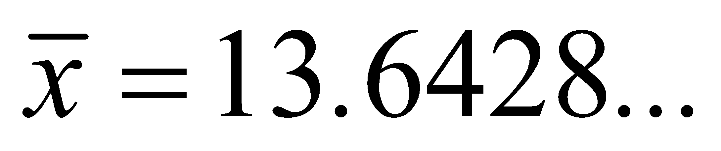 and the standard deviation, 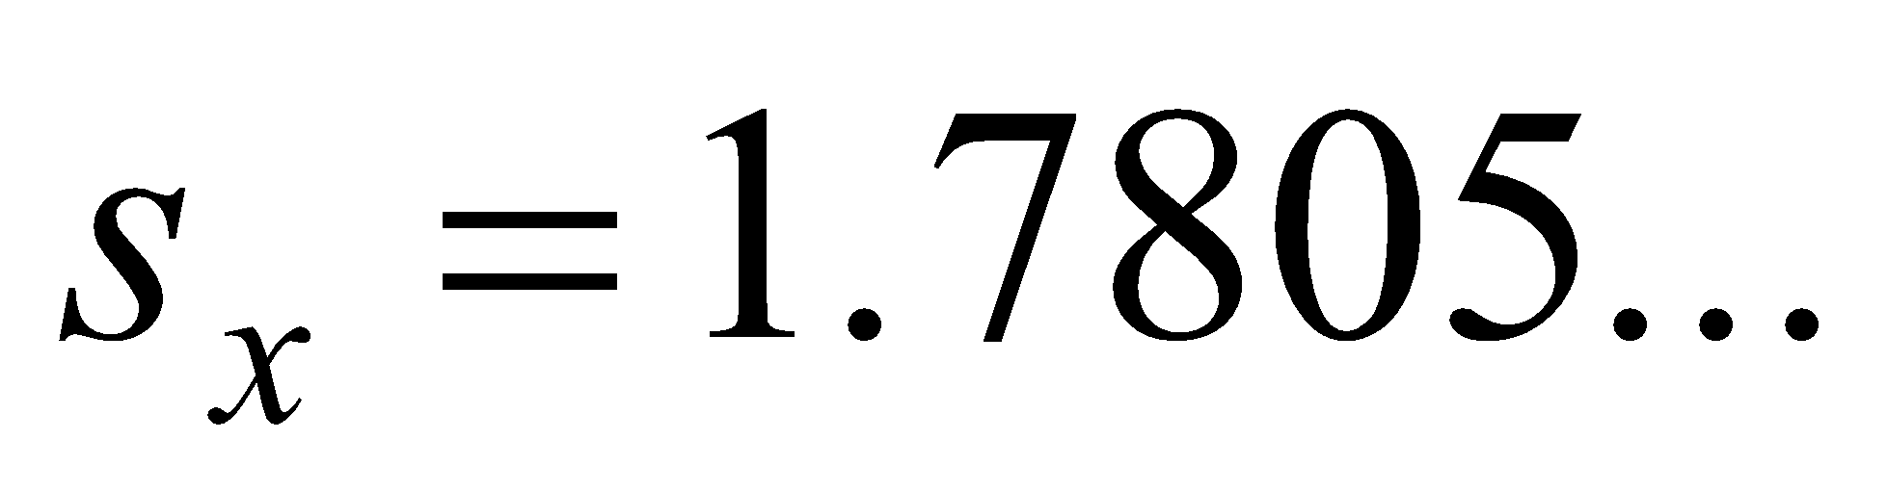.

The closest answers are 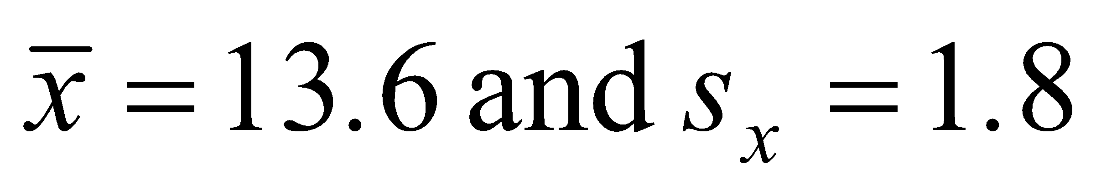.

The answer is D.

# **Question 3**

The distribution trails off to the right and has a couple of outliers.

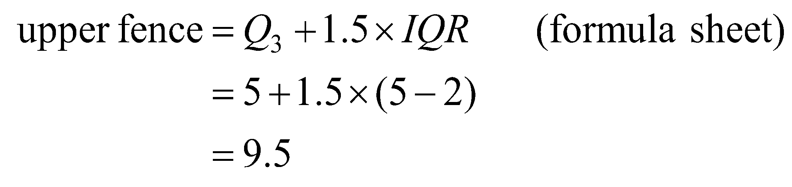

Since 

The best description is therefore “positively skewed with outliers.”

The answer is E.

**Question 4**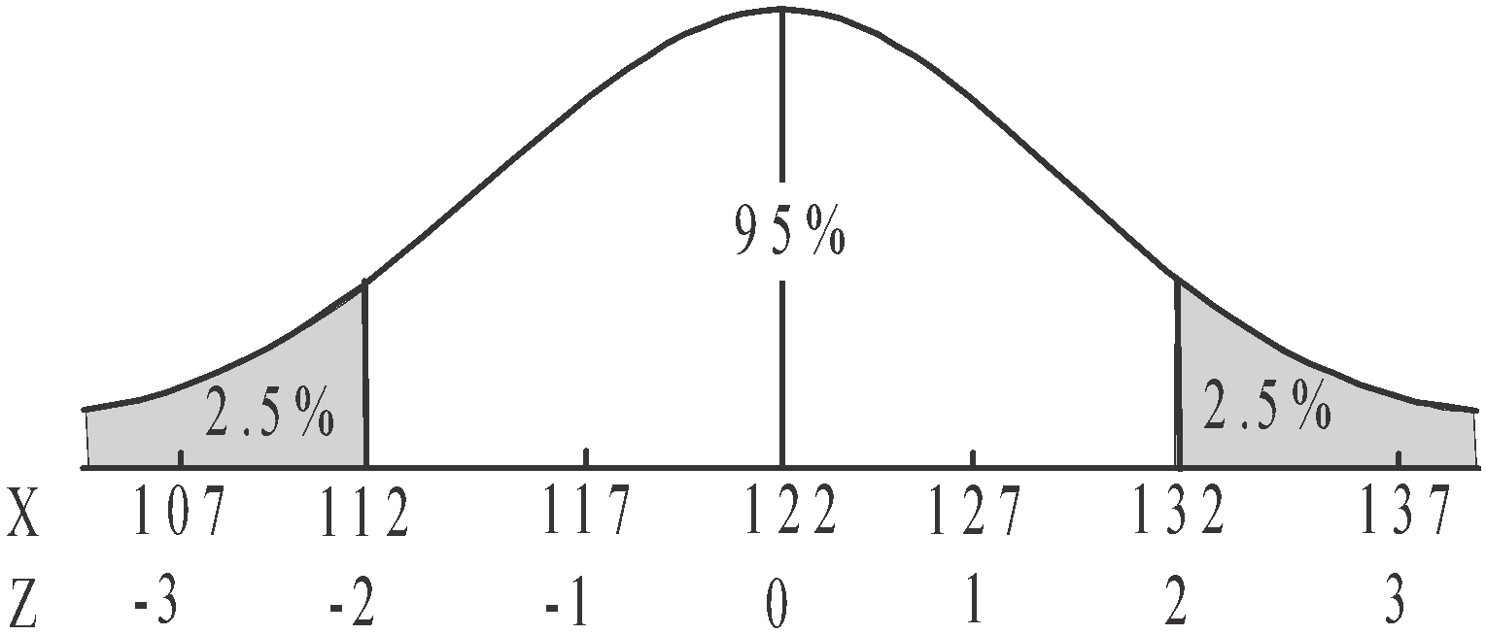

We know that 5% of the population

lies above 2 standard deviations above

the mean and below 2 standard deviations

below the mean.

So 2.5% of the population lies below

2 standard deviations below the mean.

 2.5% of the group of students are less than 112 cm in height. This means that Yasmin’s height must be 112 cm.

The answer is B.

# **Question 5**

The variable *property number*  is categorical because it places the properties into a category (of being along the highway). It also puts them in an order, so it is ordinal as well.

The variable *zoning type* is categorical because it places the properties into one of three categories. These categories aren’t in an order so the variable is nominal.

The variable *land* *area* is numerical (you can measure it) and continuous because you can have an area of 542.7692…m2 for example.

The variable *usual number of occupants* is numerical (you can count them) and discrete because you can’t have half a person.

The variable *postcode* is categorical because it places properties in a group. It is nominal not ordinal because the number is just referring to a place and the places are not in any order.

In summary, there are

* 2 nominal categorical variables
* 1 ordinal categorical variable
* 1 discrete numerical variable
* 1 continuous numerical variable.

The answer is A.

# **Question 6**

We are looking for the *number of cars owned* per capita to be more than 1.

Since 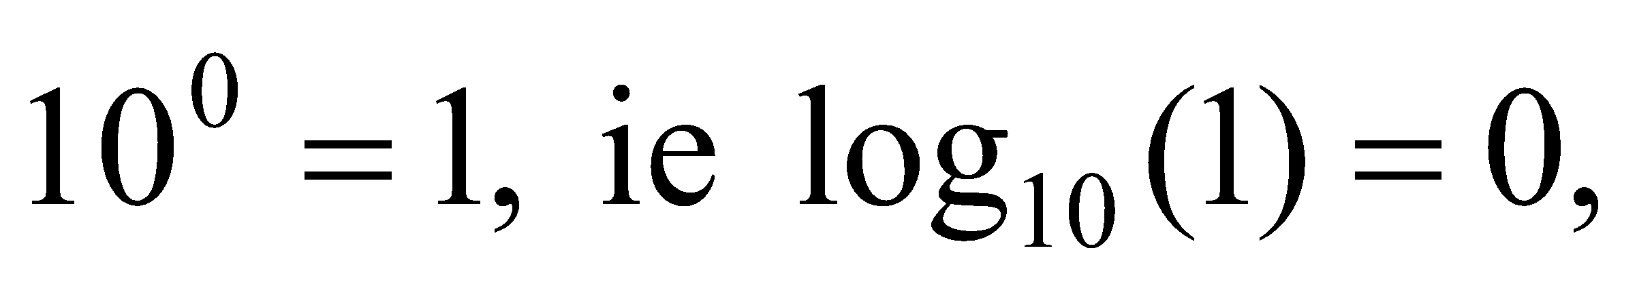 and because we have a  scale, we are looking for

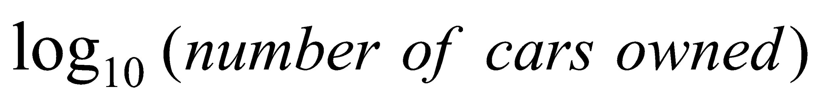 to be more than zero.

There are 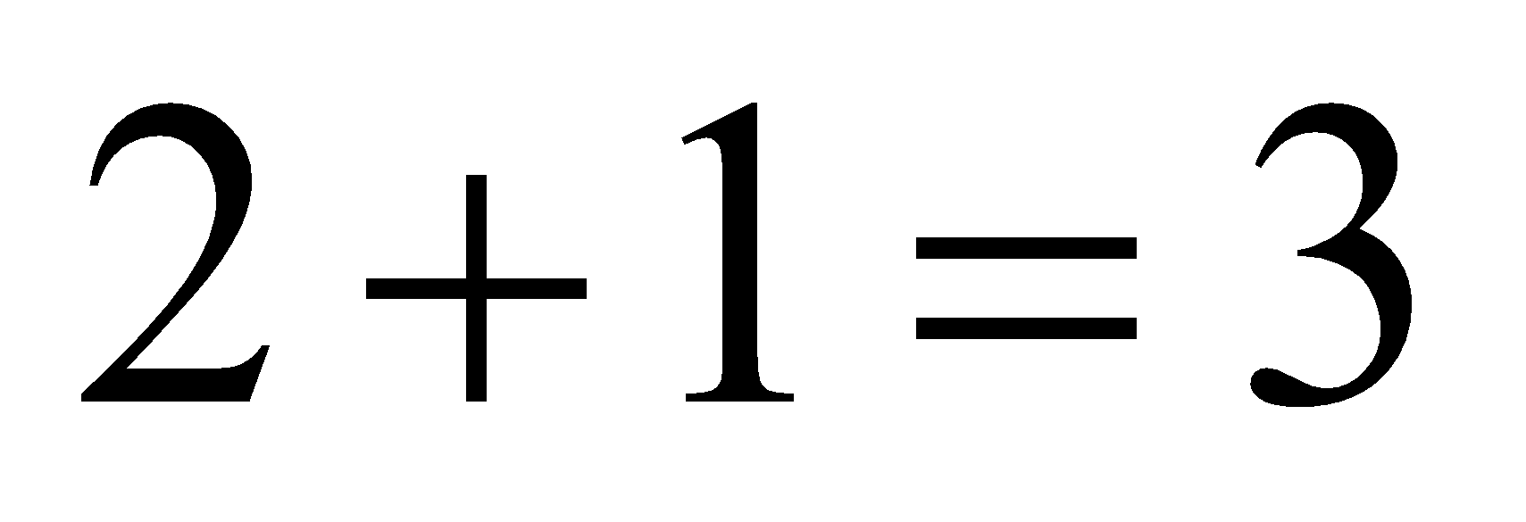 countries where this is the case.

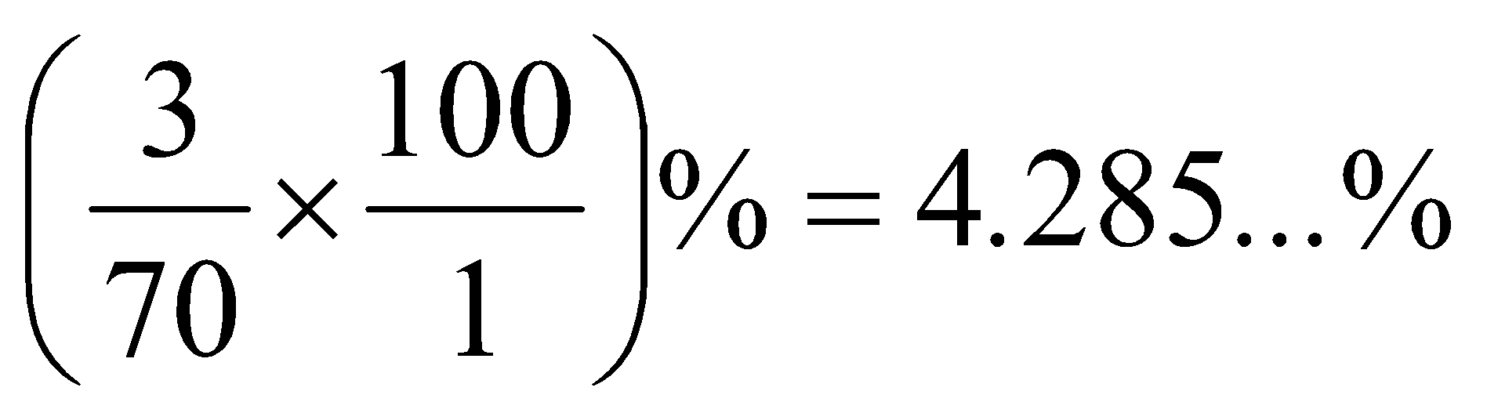

The closest answer is 4%.

The answer is C.

# **Question 7**

Read the question carefully, we are being asked about the inland town so we focus on the top boxplot.

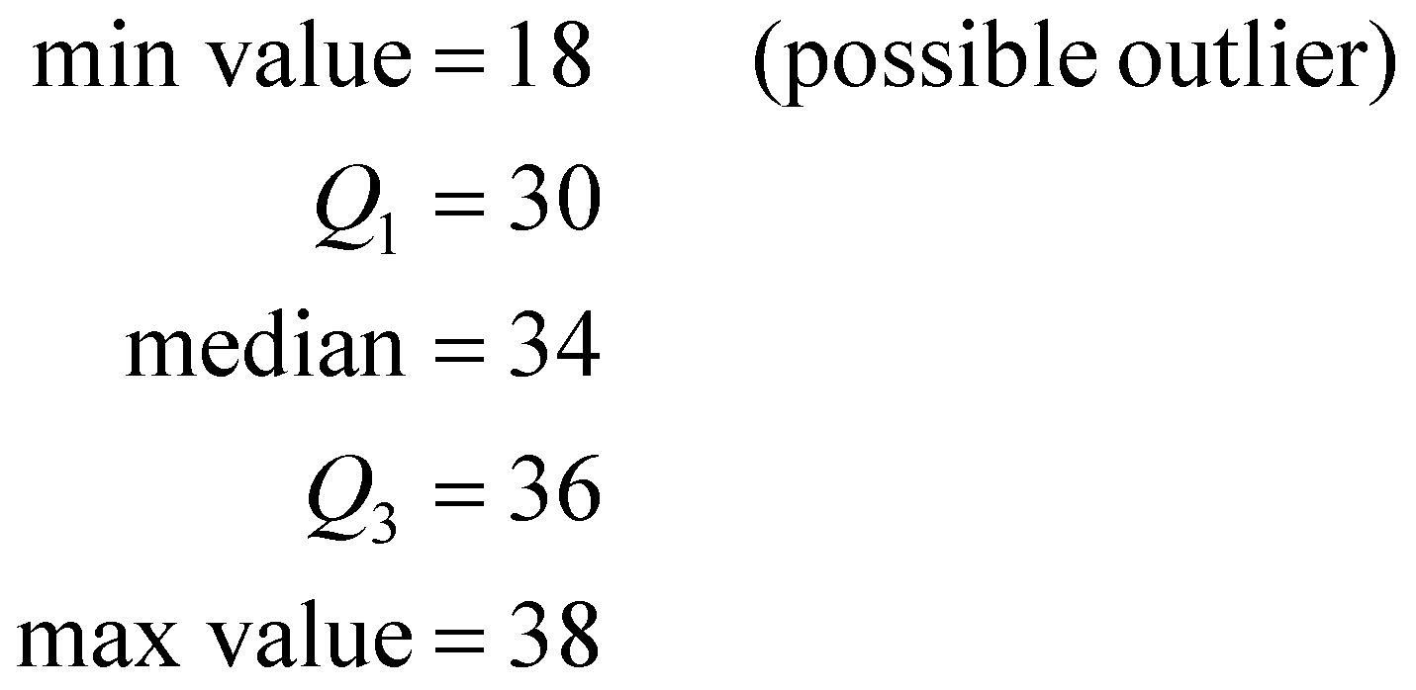

The answer is D.

**Question 8**

Options A–D are all true.

Option E is not true.

The answer is E.

# **Question 9**

Key the data into your CAS and go to the linear regression line equation option.

This option not only gives you the coefficients of the linear regression line equation (*a* and *b*) it also gives you the value of *r*, Pearson’s coefficient.

So 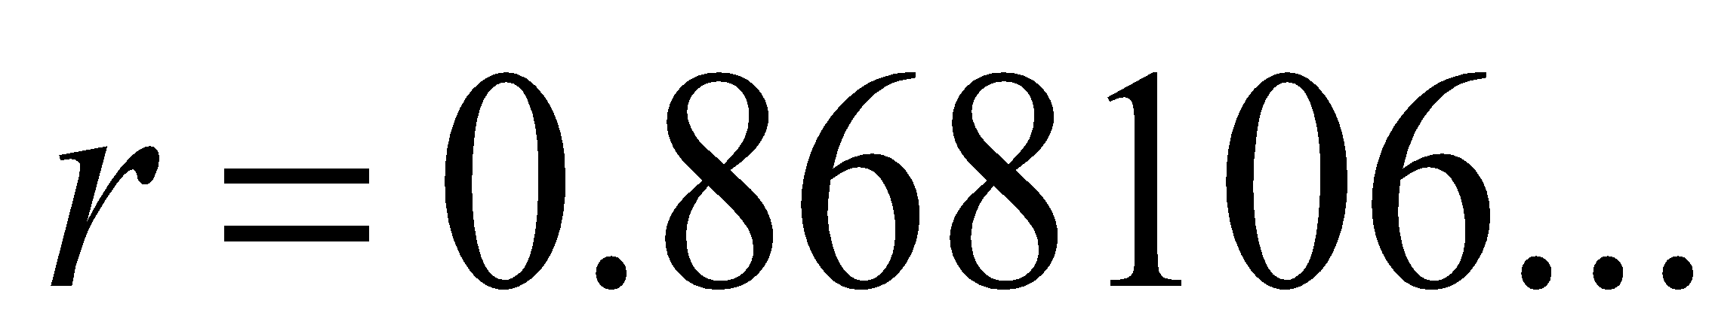

The closest value is 0.87.

Note that when you are just finding the value of *r*, it doesn’t matter whether you make the variable *wingspan* the *x* or *y* variable, as you will get the same result. It **WOULD** matter however if you had been asked to find the equation of the regression line.

The answer is E.

# **Question 10**

Option A is not true because it suggests that longer brushing causes fewer cavities. We don’t know this. We only know there is a correlation, not a causation.

Option B is not true because the project suggests a correlation.

Option C is true because it suggests a correlation that is negative (i.e. brushing time increases and cavities decrease).

The answer is C.

# **Question 11**

The annual turnover of the company shows an increasing trend between 2005–2008 and then a sharp drop in 2009. From 2009 to 2015 there is once again an increasing trend. This sudden drop represents a sudden change in a pattern which had been established on the time series plot and therefore represents a structural change.

The answer is E.

# **Question 12**

|  |  |  |  |
| --- | --- | --- | --- |
| month | data used | two-point  moving mean | two-point  moving mean  with centring |
| June | 78.5 |  |  |
|  |  |  |  |
| July | 69.7 |  |  |
|  |  |  |  |
| August | 61.3 |  |  |

The smoothed value for July is 69.8. Note, if you selected option E then you didn’t use any brackets (as shown above) which are essential. You should have noticed that the answer was not feasible because it was far removed from the values given in the question.

The answer is C.

**Question 13**

For the five points on the graph relating to the years 2012, 2013, 2014, 2015 and 2016, two points are above the 2016 attendance number of 2700, and two points are below.

That is, the 2014 attendance of 3500 and the 2015 attendance of 3000 are above 2700 (2016). The 2012 attendance of 2000 and the 2013 attendance of 2600 are below 2700 (2016).

So the smoothed number of people attending in 2014 is 2700.

The answer is B.

**Question 14**

The seasonal indices should add to give 12. The sum of the indices for the 11 months given is 10.96. The seasonal index for May is .

The answer is C.

**Question 15**



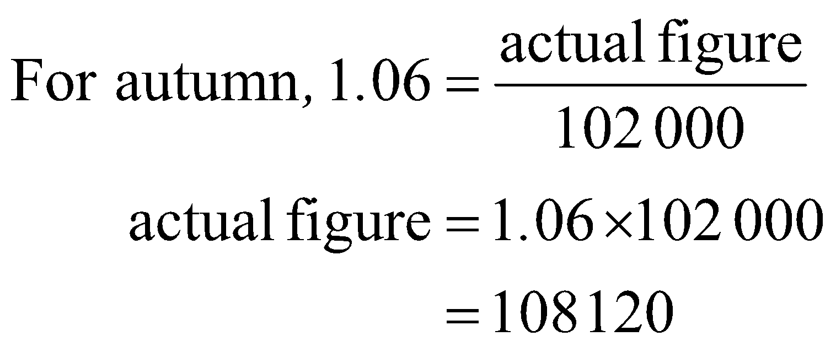

The answer is D.

**Question 16**

Start by deseasonalising the revenue.



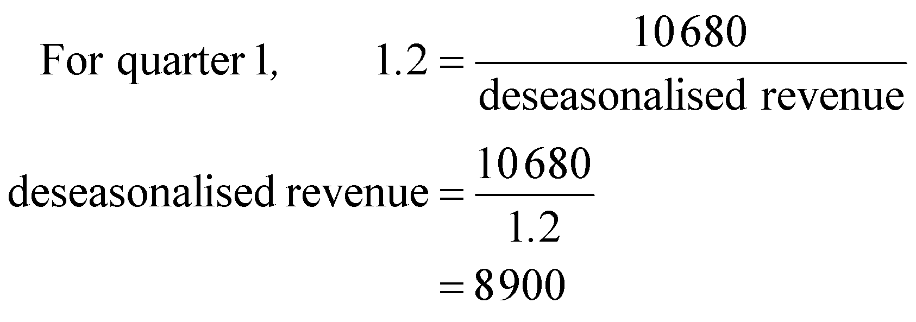

|  |  |  |  |  |
| --- | --- | --- | --- | --- |
| Quarter number | 1 | 2 | 3 | 4 |
| Revenue  ($) | 10 680 | 12 600 | 5 600 | 3 840 |
| deseasonalised revenue ($) |  |  |  |  |

Enter the data into your calculator, specifically the points (1, 8900), (2, 9000), (3, 7000) and (4, 6400). Note that *quarter number* is the explanatory (*x*) variable and *deseasonalised* *revenue* is the response (*y*) variable.

The least squares regression line is 

The answer is A.

**Recursion and financial modelling**

**Question 17**

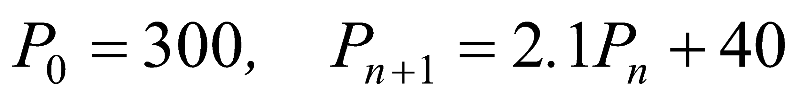

Method 1 – using CAS

Generate the sequence on your CAS.

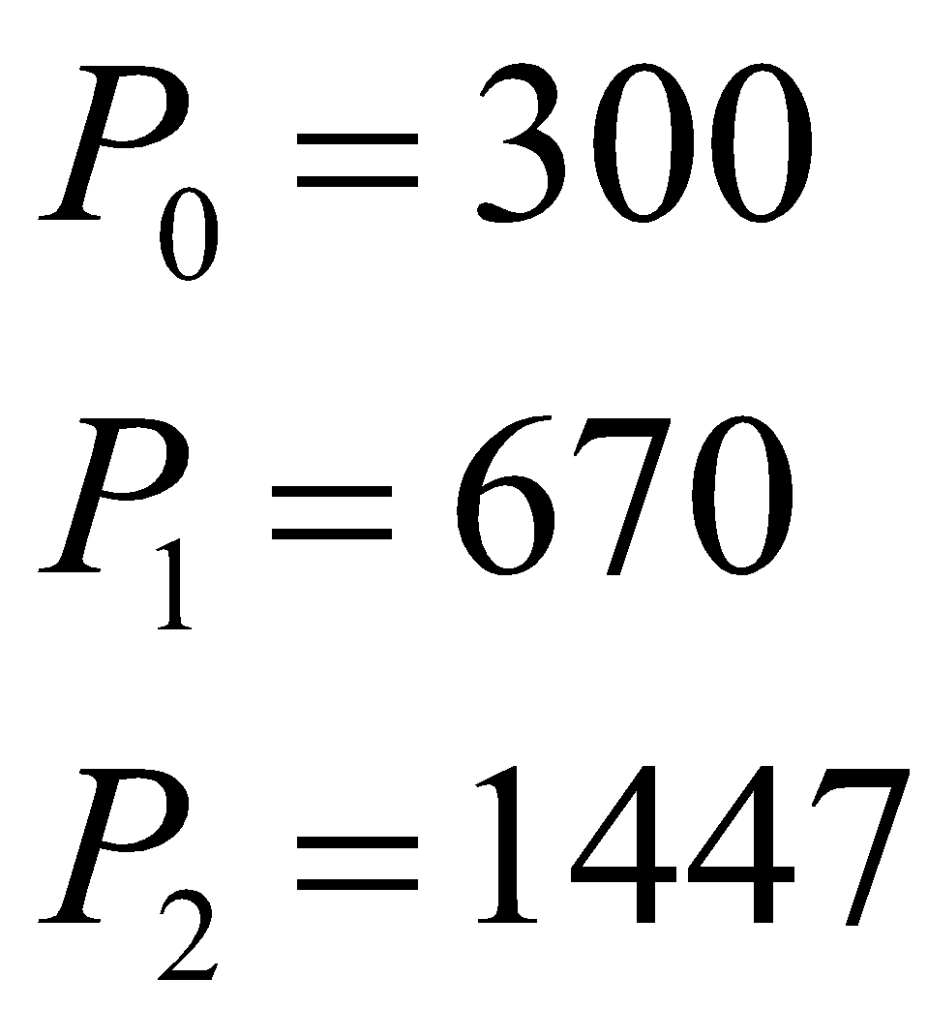

The answer is D.

Method 2 – by hand

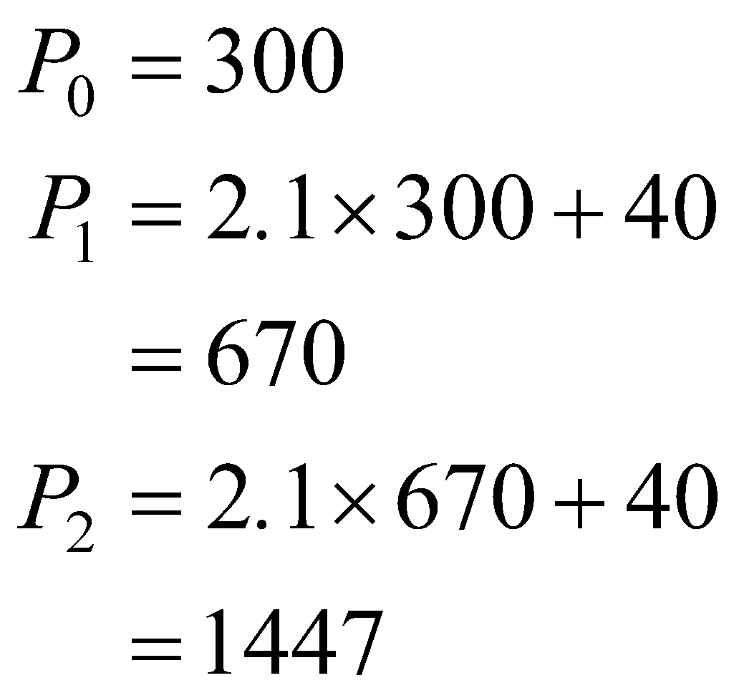

The answer is D.

**Question 18**

Generate the sequence,



Each term needs to have 0.07 (7 cents) subtracted from the previous term.

Only option D shows this.

The answer is D.

**Question 19**

Option A will show linear growth.

Option B will show geometric decay.

Option C will show geometric growth.

Option D is neither linear nor geometric. Generating the sequence however gives

750, 575, 417.5, … which shows decay rather than growth.

The answer is E.

**Question 20**

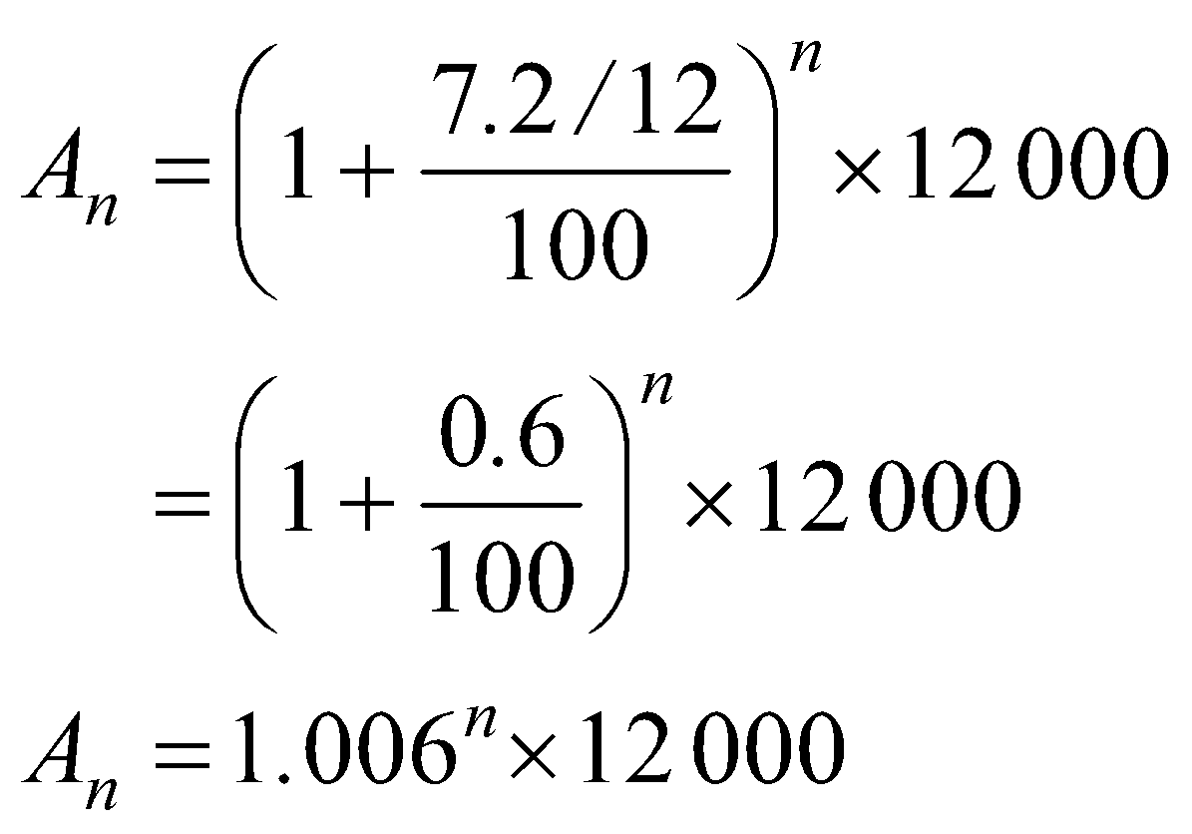

Note that the annual interest rate is 7.2% so the interest rate per month is 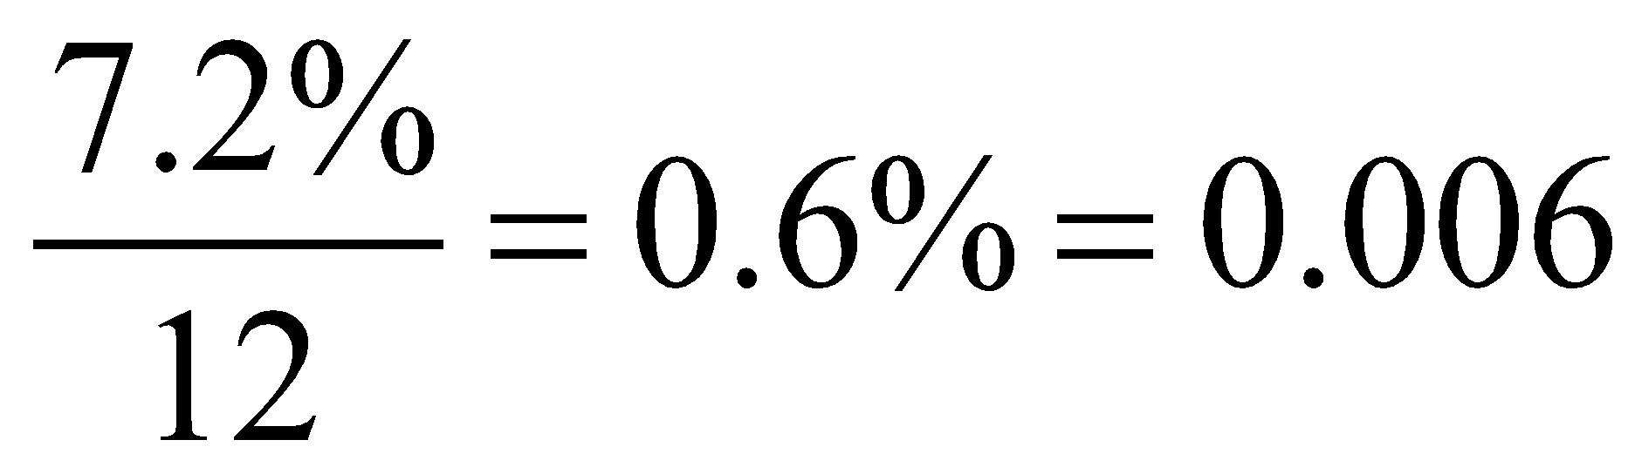.

The answer is A.

**Question 21**

Using the formula from the formula sheet, and substituting 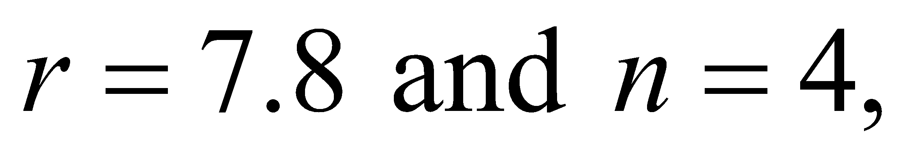 we have

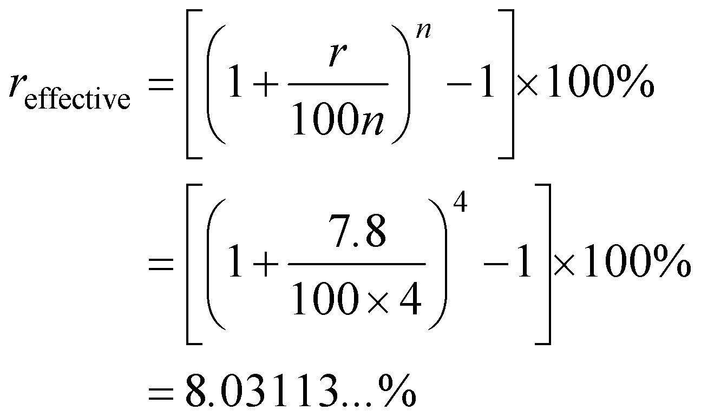

The answer is E.

**Question 22**

The graph shows geometric growth; that is, the value of the investment is increasing a little more each year than it did the previous year. That annual geometric growth looks to be about 10% since the value of the investment to start with was $10 000 and at the end of the first year it was about $11 000.

Options A and B can be eliminated because they show linear decay and growth respectively. If we had linear growth or decay then we would be able to rule a straight line through the points which we can’t.

Option C can be eliminated because it shows geometric decay.

Option D can be eliminated because it shows geometric growth of 1% per year whereas as mentioned previously the growth is more like 10%.

The answer is E.

**Question 23**

The balance of the loan after one repayment has been made equals

 or alternatively 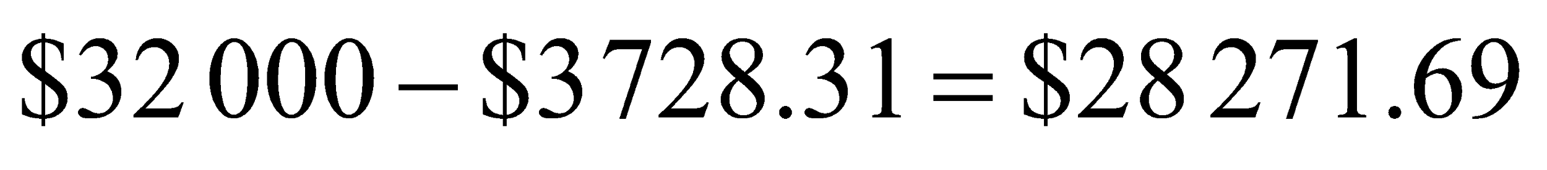

The answer is C.

**Question 24**

The interest charged is

2% of $20 589.88

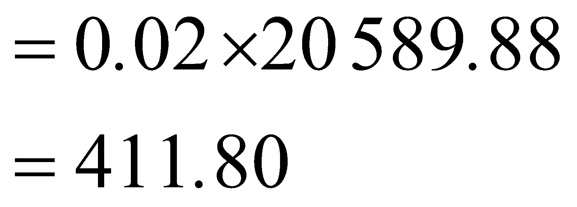

The reduction in principal after payment number four is

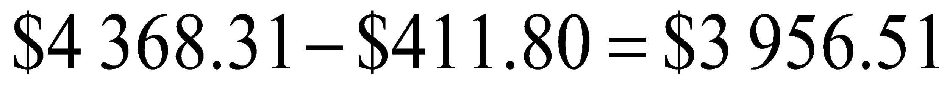

The answer is B.

**SECTION B - Modules**

**Module 1: Matrices**

**Question 1**

The number of sick days taken by Carrie in 2014 was 3. This element in the matrix is in the second row and the third column so it is represented by 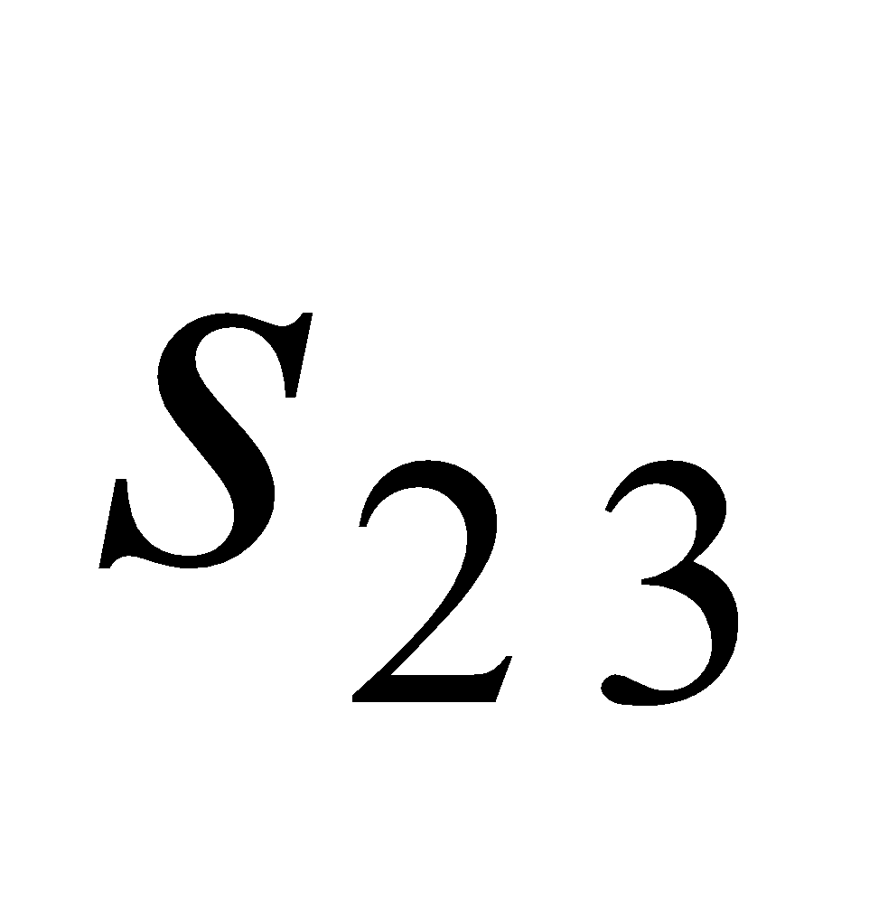.

The answer is B.

# **Question 2**

We need to find 3 totals which could be presented as a 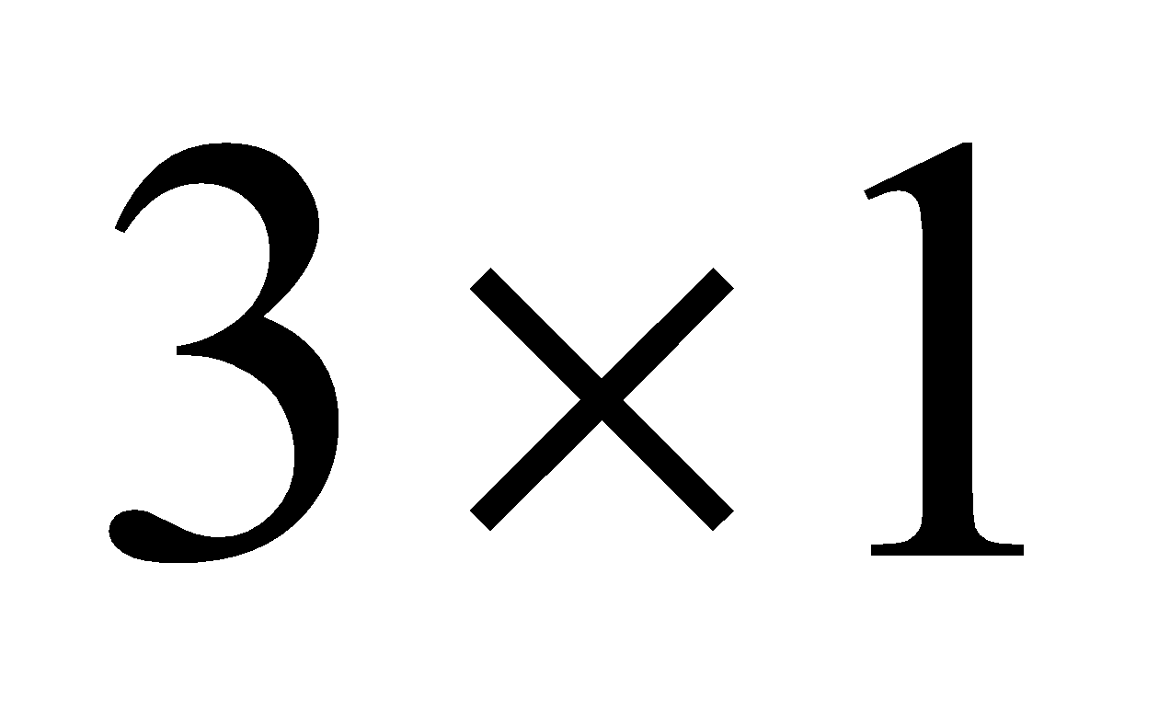 matrix or a  matrix.

For option A, the number of columns of the first matrix is 1 and the number of rows of the second matrix is 3 so this product is not defined.

For option B, the number of columns of the first matrix is 1 and the number of rows of the second matrix is 2 so this product is not defined.

For option C, the number of columns of the first matrix is 2 and the number of rows of the second matrix is 2 so the matrix product is defined. However, the resulting matrix is a 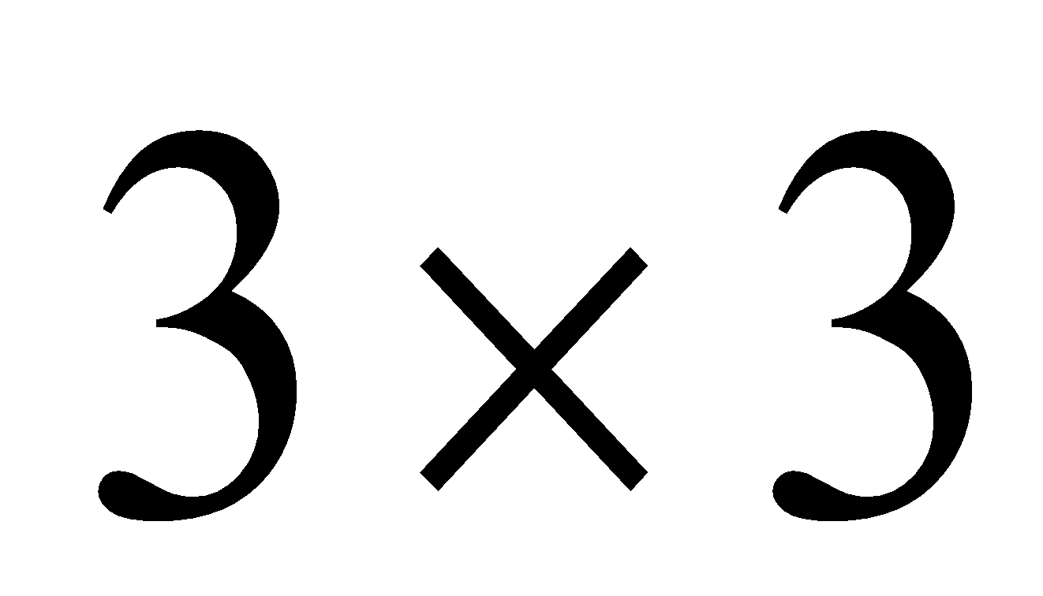 matrix whereas we want a  matrix or a 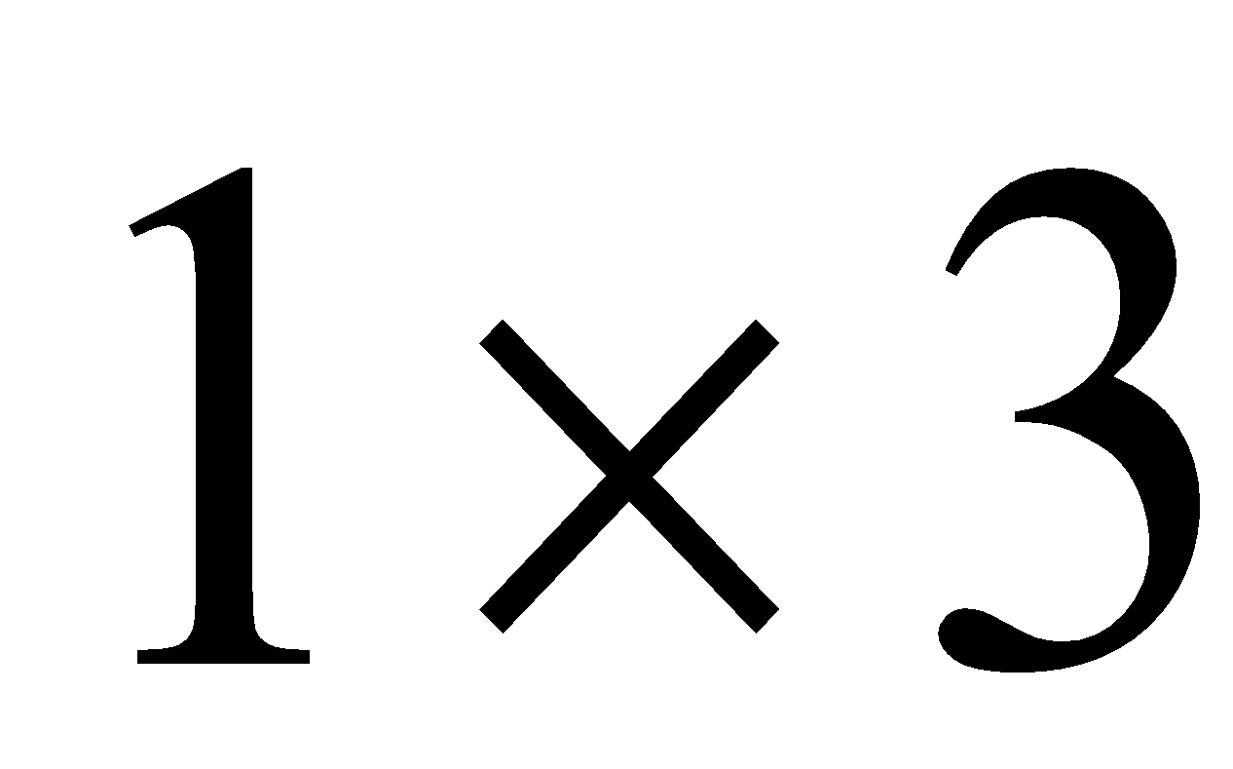 matrix.

For option D the number of columns of the first matrix is 3 and the number of rows of the second matrix is 2 so this product is not defined.

The answer is E.

# **Question 3**

We need to find a steady state.

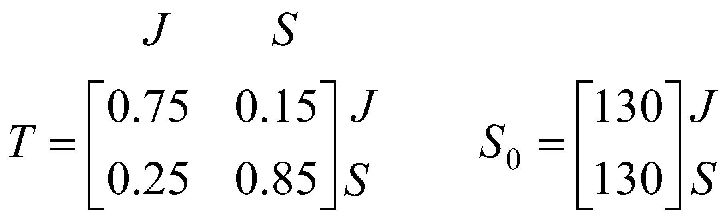

Use the rule 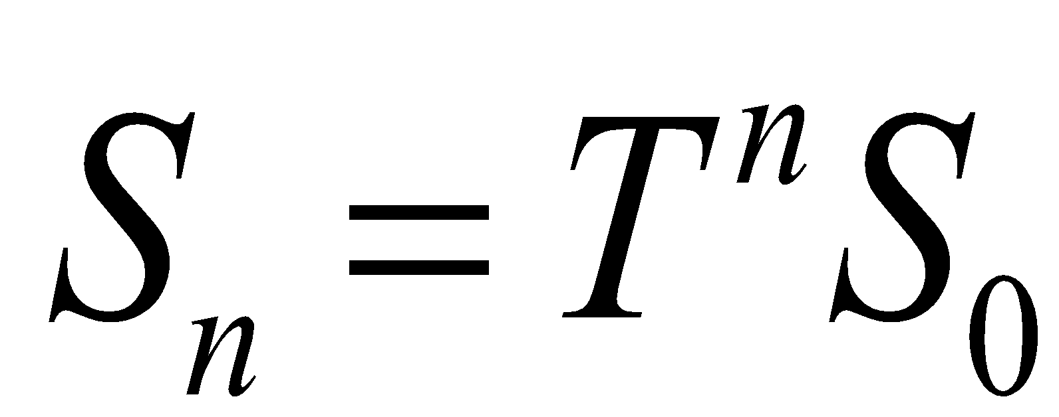

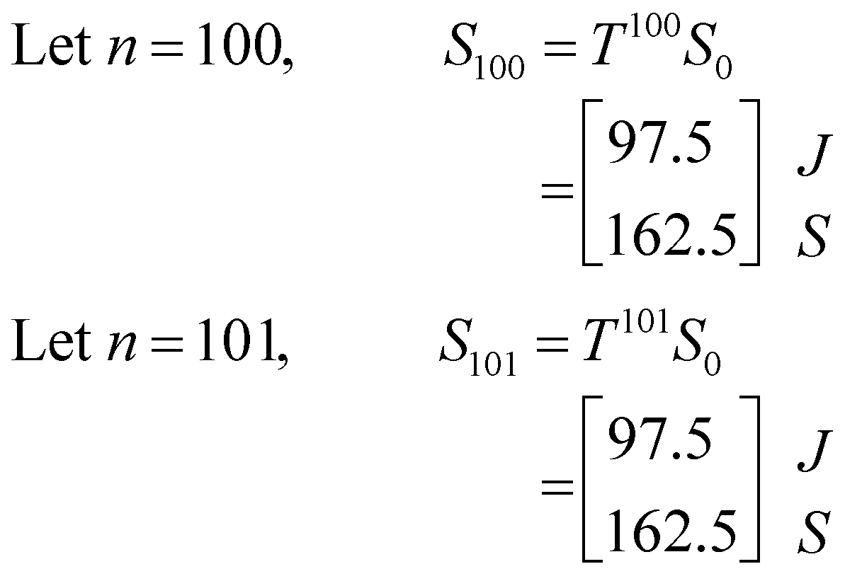

There is no change from one state (the 100th) to the next state (the 101st). A steady state has been reached. Over the long term, Sudhir is expected to be chosen by 163 patients (to the nearest whole number).

The answer is D.

# **Question 4**

Each of these sets of equations can be written in matrix form.

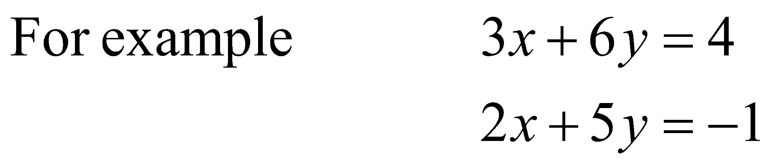

can be written as 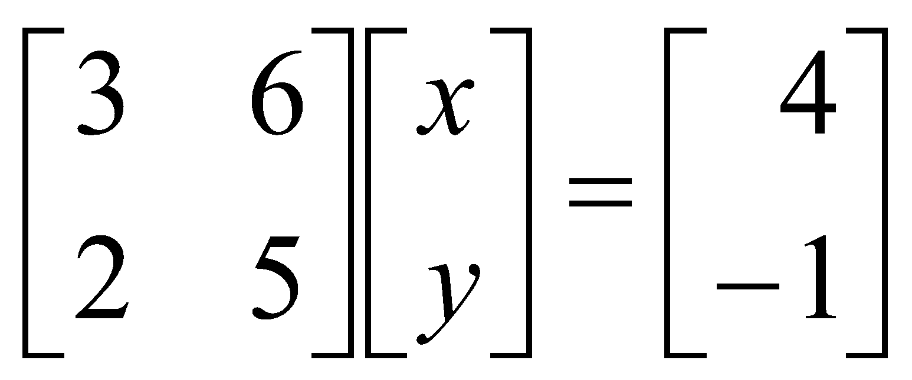

For the  matrix, the determinant is given by 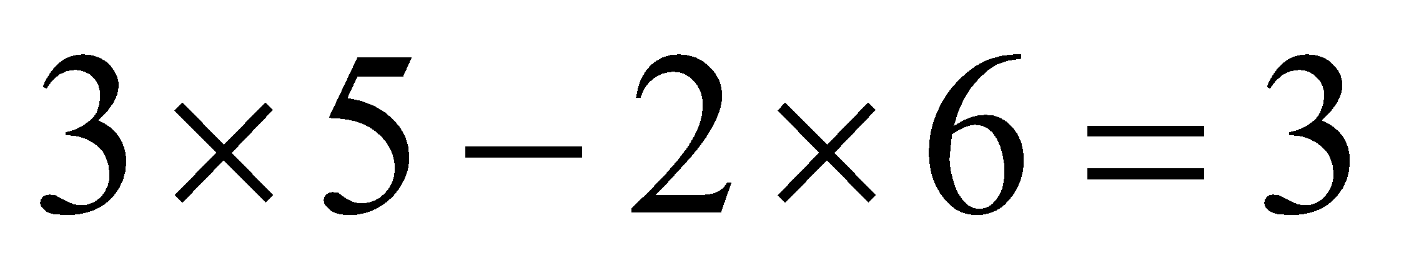.

Since , there is a unique solution.

For the second set of equations, 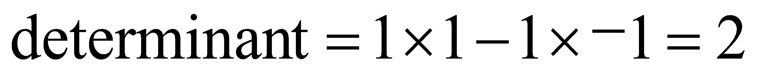.

Since , there is a unique solution.

For the third set of equations, 

Since 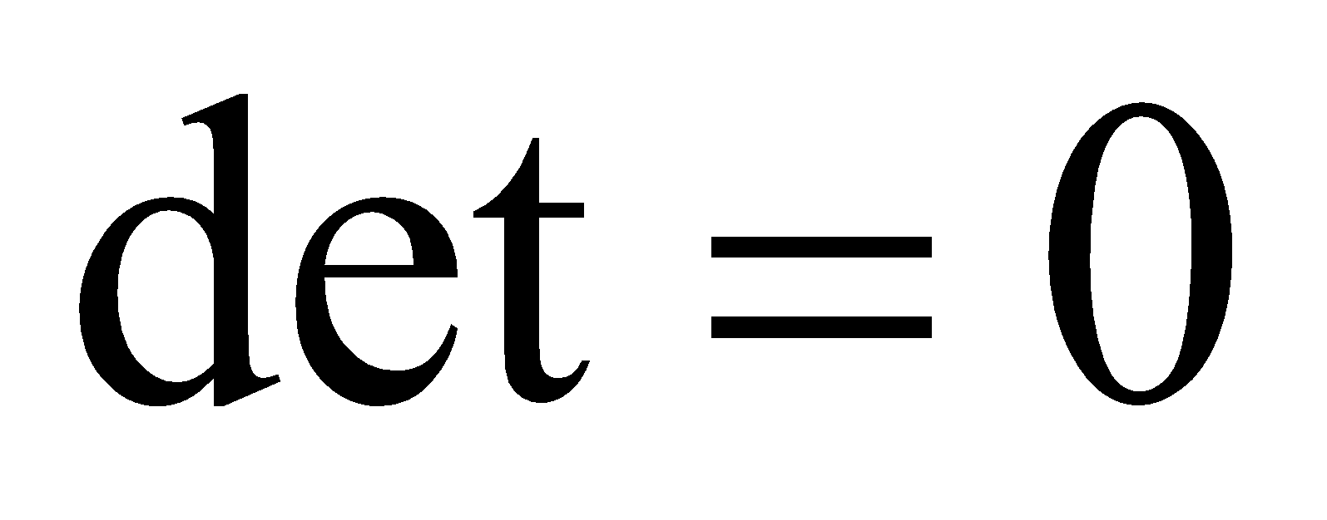there is no solution or there are infinite solutions.

For the last set of equations, .

Since , there is a unique solution.

So three sets of equations have a unique solution.

The answer is D.

# **Question 5**

Start with the 6B column. He visits 6B on Thursdays.

For option A, he will visit 6C on Friday and then 6E on Monday. Eliminate option A.

For option B, he will visit 6A on Friday and then 6C on Monday and then 6B on Tuesday. Eliminate option B.

For option C, he will visit 6D on Friday and then 6A on Monday and then 6E on Tuesday as required.

The answer is C.

# **Question 6**

Matrix *P* is a column matrix so eliminate options A and E.

Matrix *P* can be written as

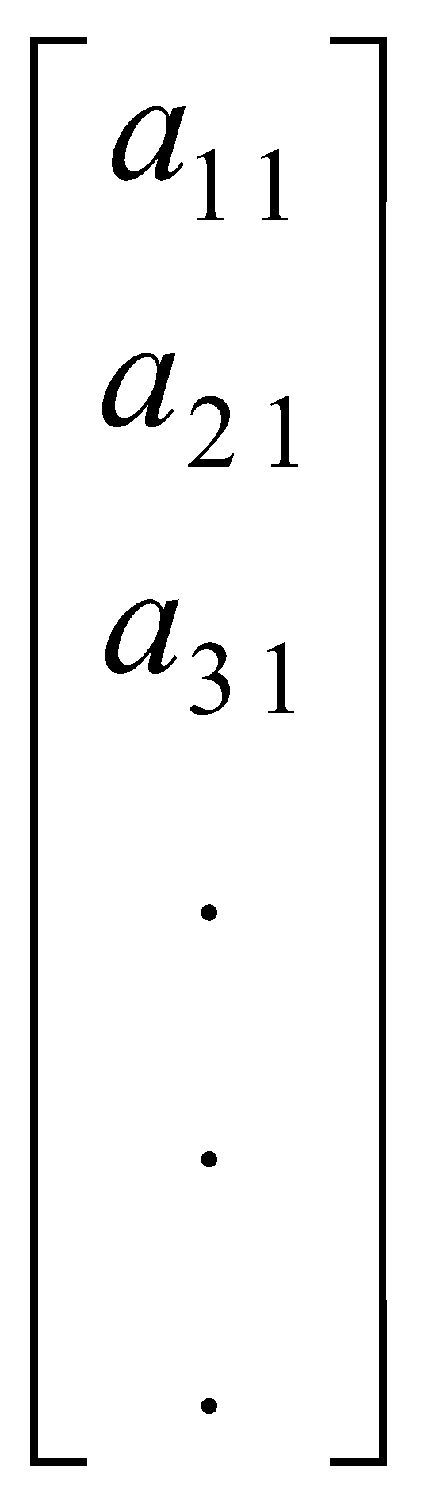

We don’t know the exact order of matrix *P* other than it has just one column.



The answer is D.

# **Question 7**

This information can be represented by a system of simultaneous linear equations.

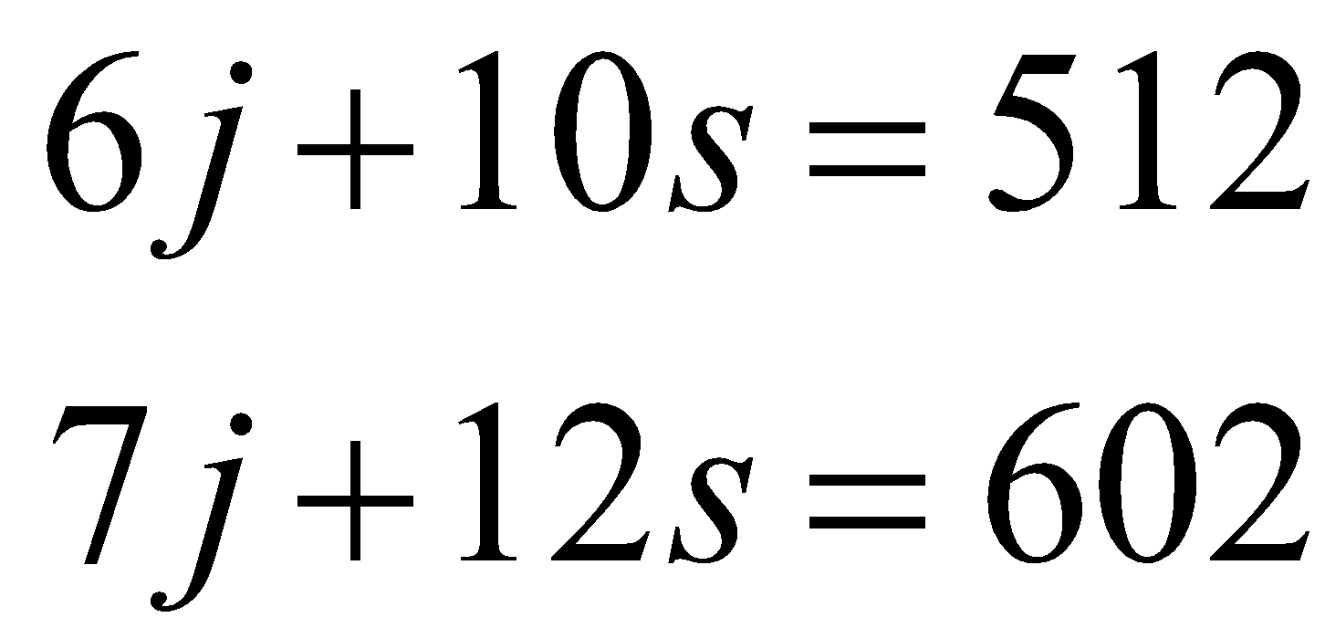

This system can be expressed in matrix form.

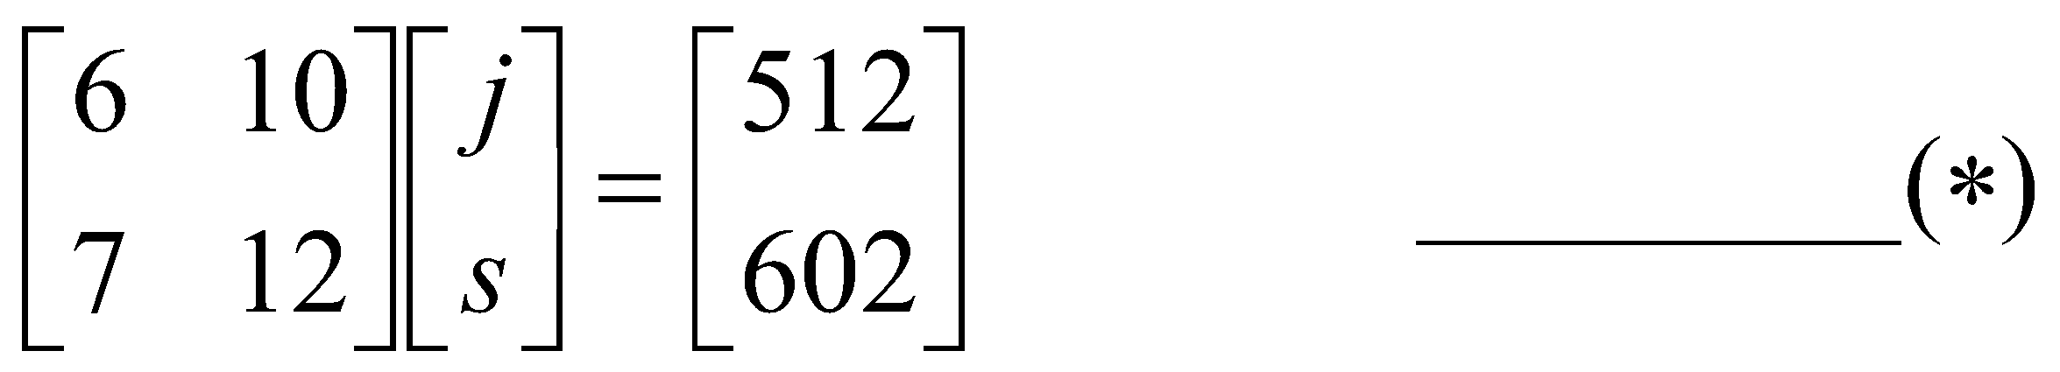

The determinant of the 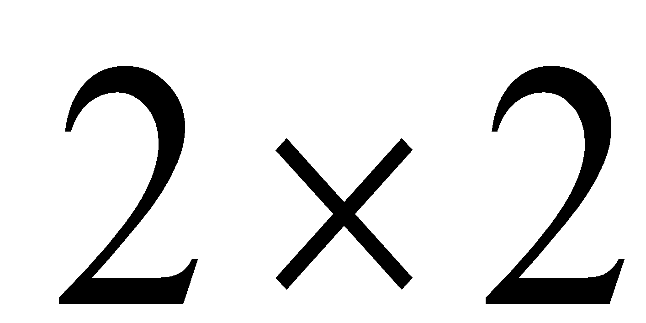 matrix is 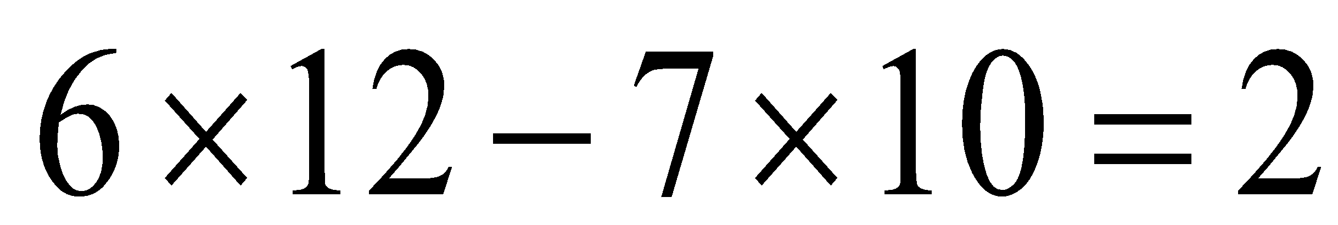.

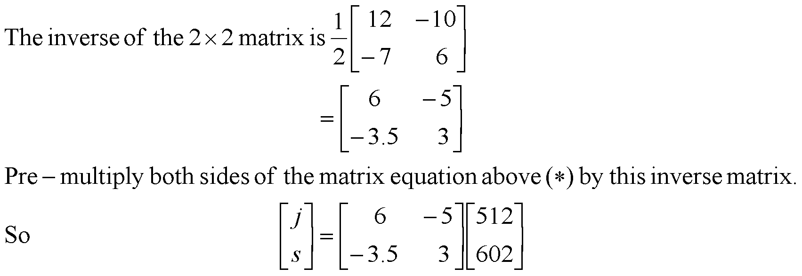

The answer is C.

# **Question 8**

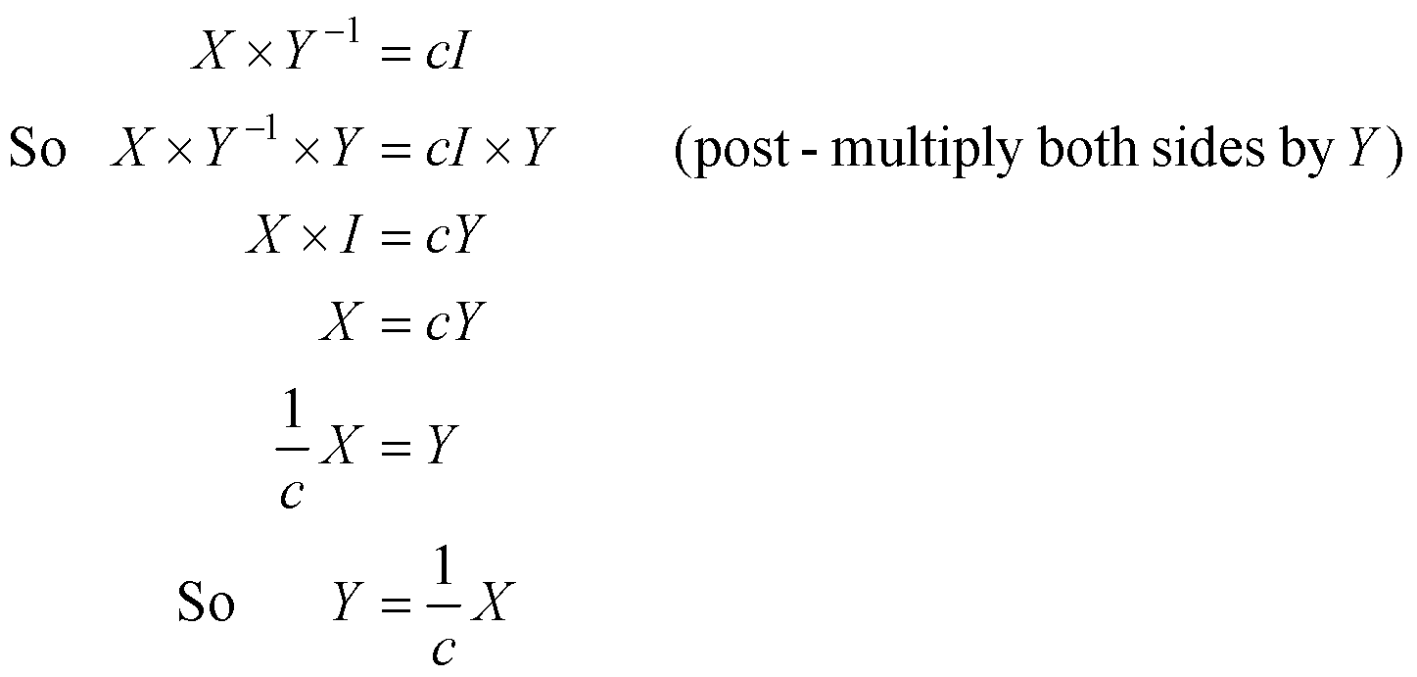.

The answer is A.

**Module 2: Networks and decision mathematics**

**Question 1**

An Eulerian trail follows every edge of a graph and only exists if the graph is connected and has just two vertices with odd degrees.

Vertices *P*, *R*, *T* and *V* have degrees of 4.

Vertices *Q* and *S* have degrees of 3.

So an Eulerian trail exists for this graph and the starting or finishing vertices would have to be *Q* and *S*.

The answer is B.

# **Question 2**

The adjacency matrix tells us that the graph has 7 edges.

You can do a quick sketch of the graph to confirm that the graph has 7 edges.

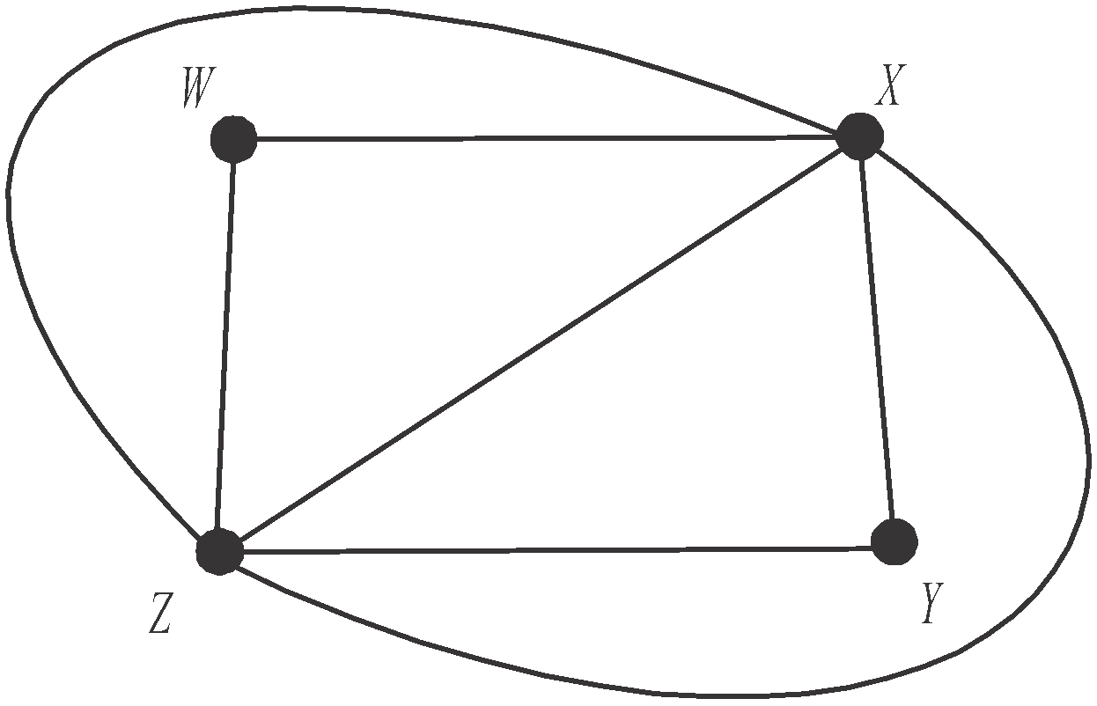

Since the graph is planar we can use Euler’s formula

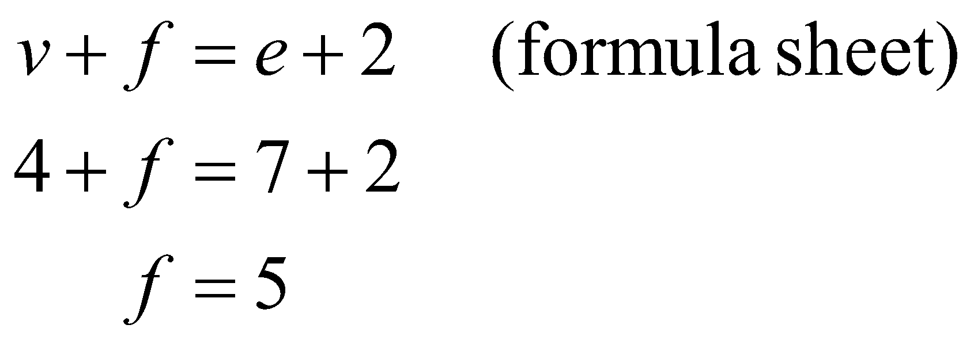

Alternatively, there are 5 regions on the graph, 4 enclosed and the remaining one is the region outside these 4.

The answer is B.

# **Question 3**

For option A, David is prepared to be president, Andrew vice-president and Harry secretary but Tom is not prepared to be treasurer.

For option B, Tom is prepared to be president, Andrew vice-president and Harry secretary but David is not prepared to be treasurer.

For option C, David is prepared to be president, Andrew vice-president, Tom secretary and Harry treasurer.

This allocation is feasible.

The answer is C.

# **Question 4**

Using the Hungarian algorithm, start with the time matrix.

|  |  |  |  |
| --- | --- | --- | --- |
| 3 | 4 | 2 | 3 |
| 2 | 3 | 4 | 3 |
| 6 | 5 | 7 | 8 |
| 9 | 8 | 10 | 7 |

Subtract the minimum entry in each row from each entry in that row.

|  |  |  |  |
| --- | --- | --- | --- |
| 1 | 2 | 0 | 1 |
| 0 | 1 | 2 | 1 |
| 1 | 0 | 2 | 3 |
| 2 | 1 | 3 | 0 |

We have an allocation evident immediately.

Bastian should do task B.

Gayle should do task C.

Robert should do task A.

Dimitri should do task D.

The minimum time is therefore 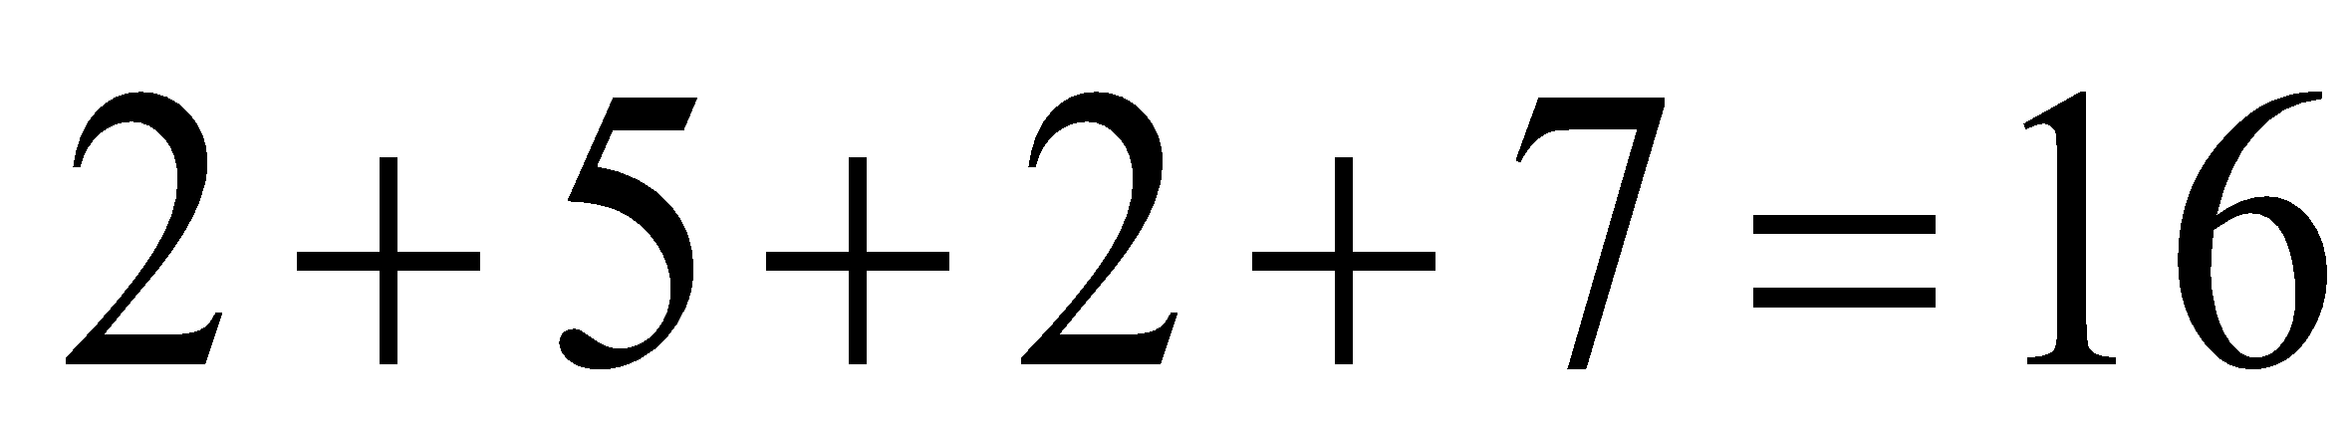 hours.

The answer is E.

# **Question 5**

Method 1 – inspection

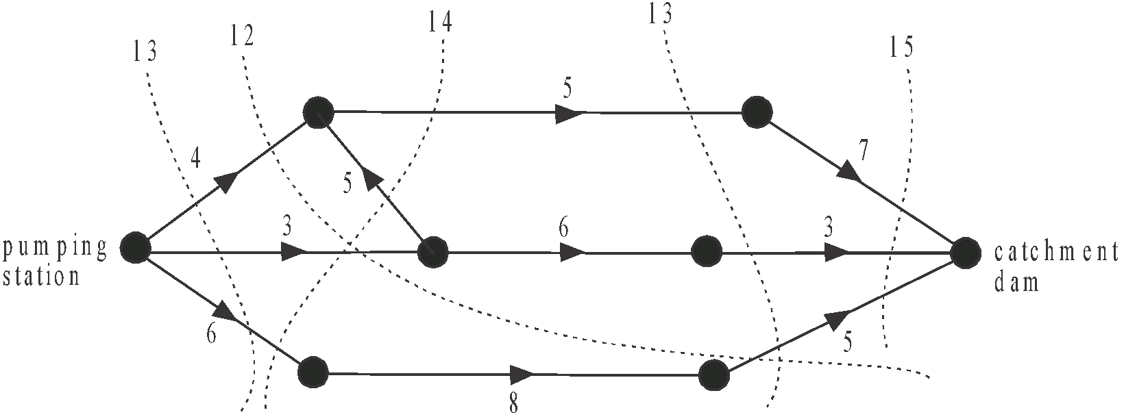

Make some cuts across the system.

Make sure that the cuts separate the pumping station from the catchment dam.

We are looking for the cut with the least capacity i.e. the minimum cut.

The minimum cut is 12.

So the maximum flow is 12 megalitres per hour.

The answer is C.

Method 2

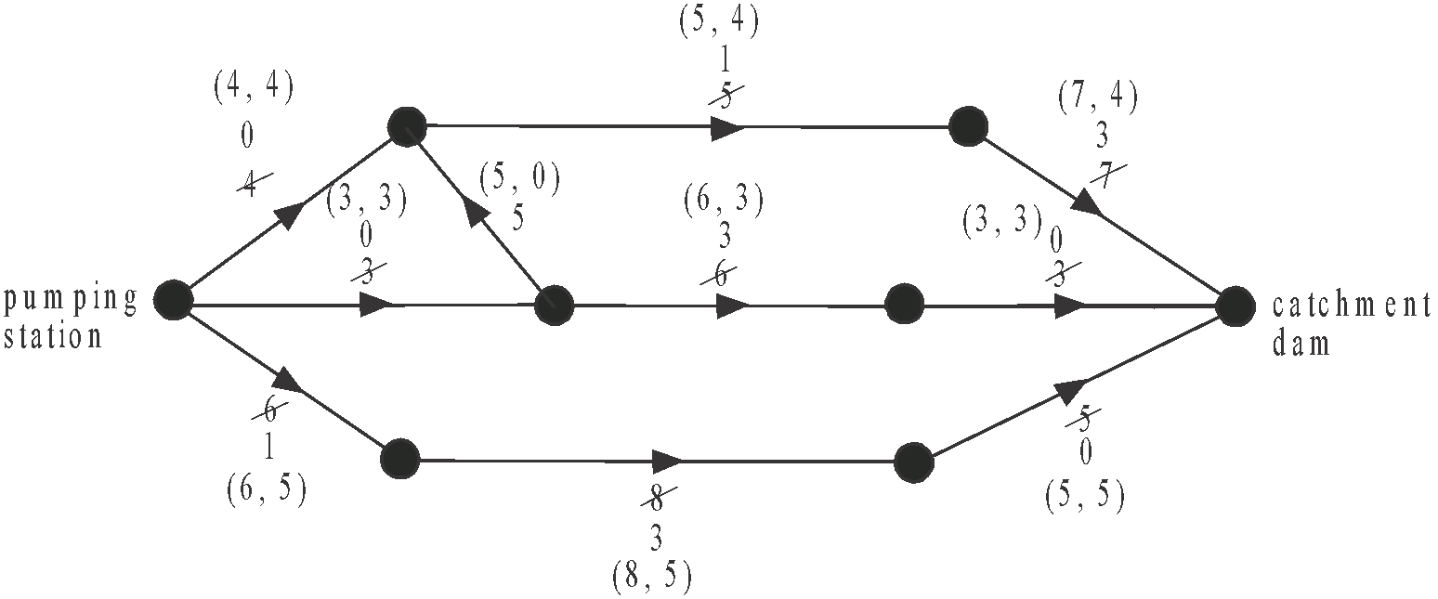

Start with the ‘upper’ path where a maximum of 4 megalitres/hour can flow through.

Next look at the ‘middle’ path where a maximum of 3 megalitres/hour can flow through.

Finally look at the ‘lower’ path where a maximum of 5 megalitres/hour can flow through.

The ordered pairs on each edge give (initial capacity, final flow).

The sum of the final flows out of the pumping station is 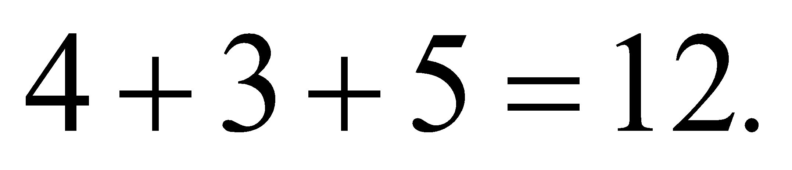

The sum of the final flows into the catchment dam is 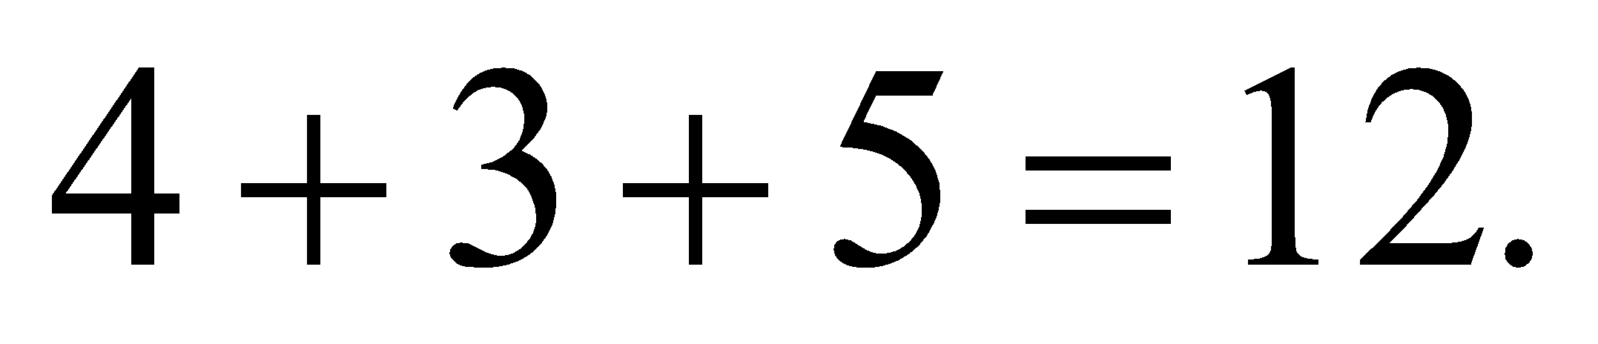

The maximum flow possible is 12 megalitres per hour.

The answer is C.

**Question 6**

The solution to this problem requires finding a minimum spanning tree.

Start with the minimum edge, which is 90 and keep adding edges to find the minimum spanning tree which is indicated below by the solid lines.

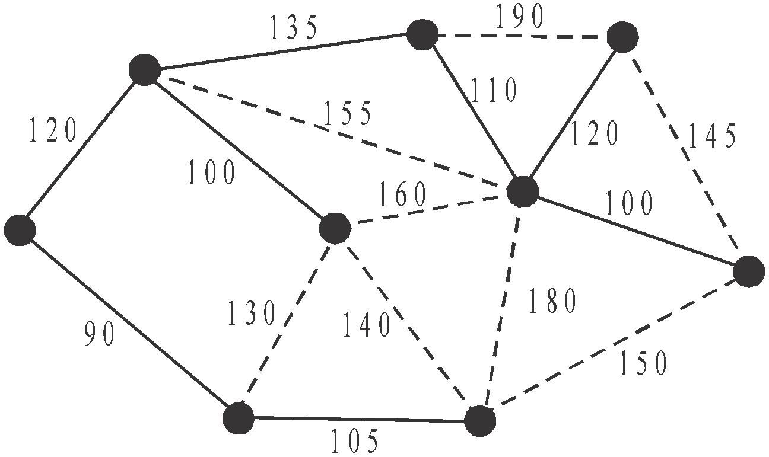

The minimum cost is 

The answer is A.

**Question 7**

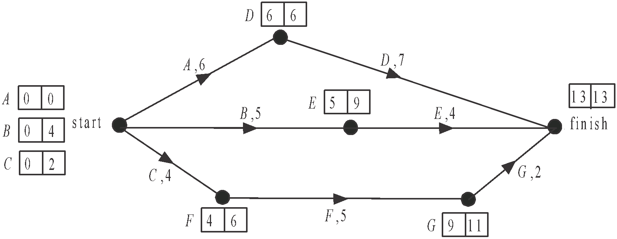

Do a forward and backward scan.

Activities *B* and *E* each have a float time of 4 days.

Activities *A* and *D* each have a float time of 0 days, that is, they lie on the critical path.

Activities *C*, *F* and *G* each have a float time of 2 days.

So activities *B* and *E* have the greatest float times.

The answer is B.

# **Question 8**

Using the graph from Question 7, we see that activities *A* and *D* are on the critical path.

The minimum time to complete these activities is 13 days.

Activities *B* and *E* will take 9 days.

Activities *C*, *F* and *G* will take 11 days.

The shortest completion time possible after the crashing of the project will be 10 days. This can be achieved by reducing activity *A* by 3 days which will cost 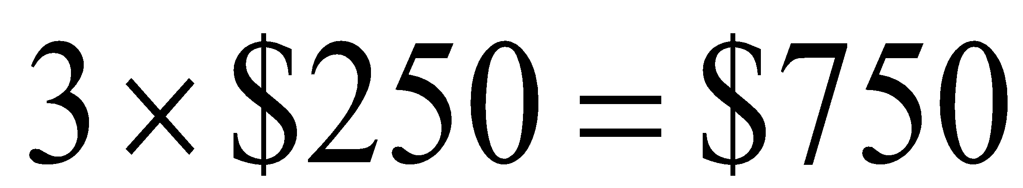

Activity *C* will need to be reduced by 1 day.

The total cost will be 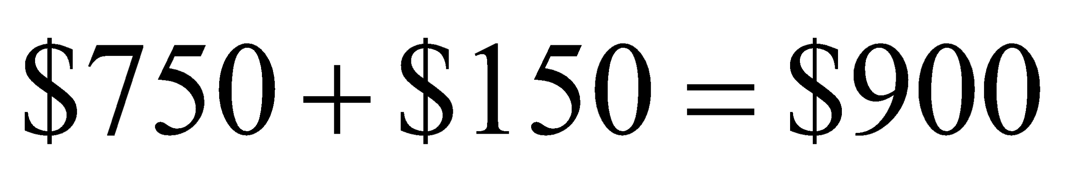

The answer is D.

**Module 3: Geometry and measurement**

**Question 1**

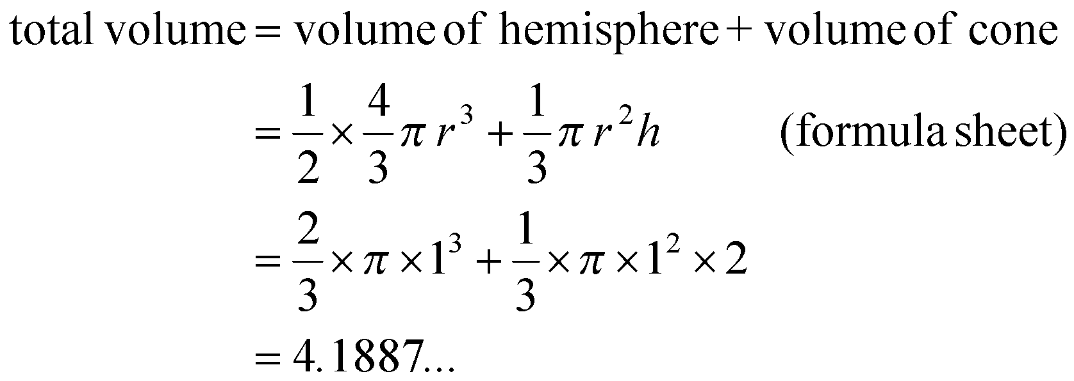

The closest answer is 4.2.

The answer is B.

# **Question 2**

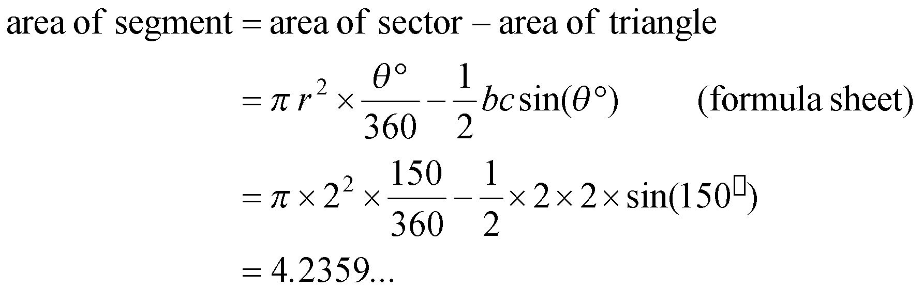

The closest answer is 4.2.

The answer is D.

# **Question 3**

The first thing to note about Δ*ABC* is that it is a non right-angled triangle so the trigonometric ratios cannot be used, so eliminate option B.

The cosine rule can be used. (formula sheet)

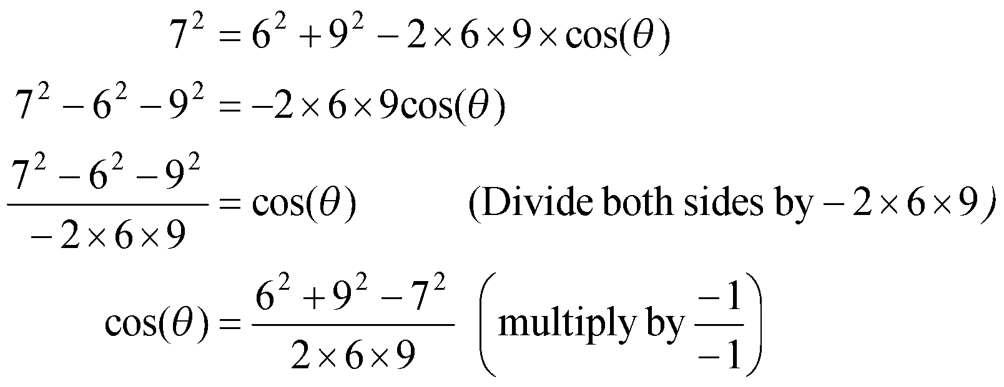

The answer is C.

# **Question 4**

Since Paris is nine hours behind Melbourne, then when Julie and Peter left Melbourne at 11.30am on Tuesday, it was 2.30am on Tuesday in Paris.

The time that elapses in Paris between 2.30am on Tuesday and 6am on Wednesday is 24 hours + 3.5 hours.

Their travel time was a total of 27.5 hours.

The answer is C.

# **Question 5**

Draw a diagram.

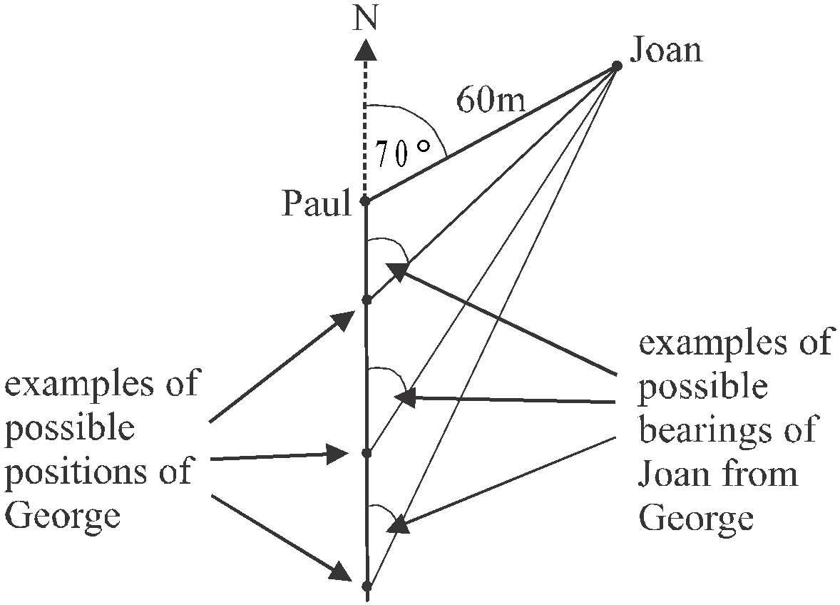

We see that the bearing of Joan from George must be less than 070°, i.e. the further George moves south the smaller the bearing becomes.

The bearing cannot equal 070° because then George would be standing where Paul is and we are told he is ‘some distance due south of Paul’.

The answer is A.

# **Question 6**

The ratio of the volumes of the cones is given by

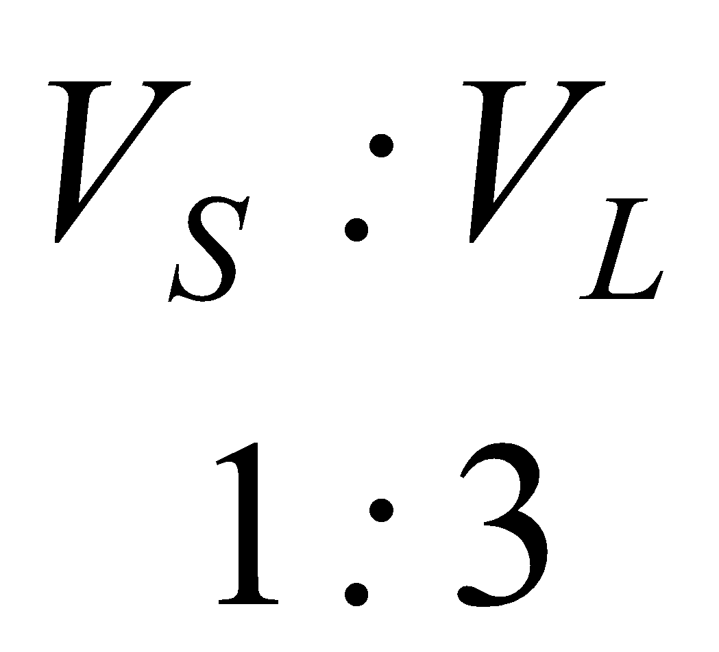

Therefore the ratio of the radius of the cones is given by

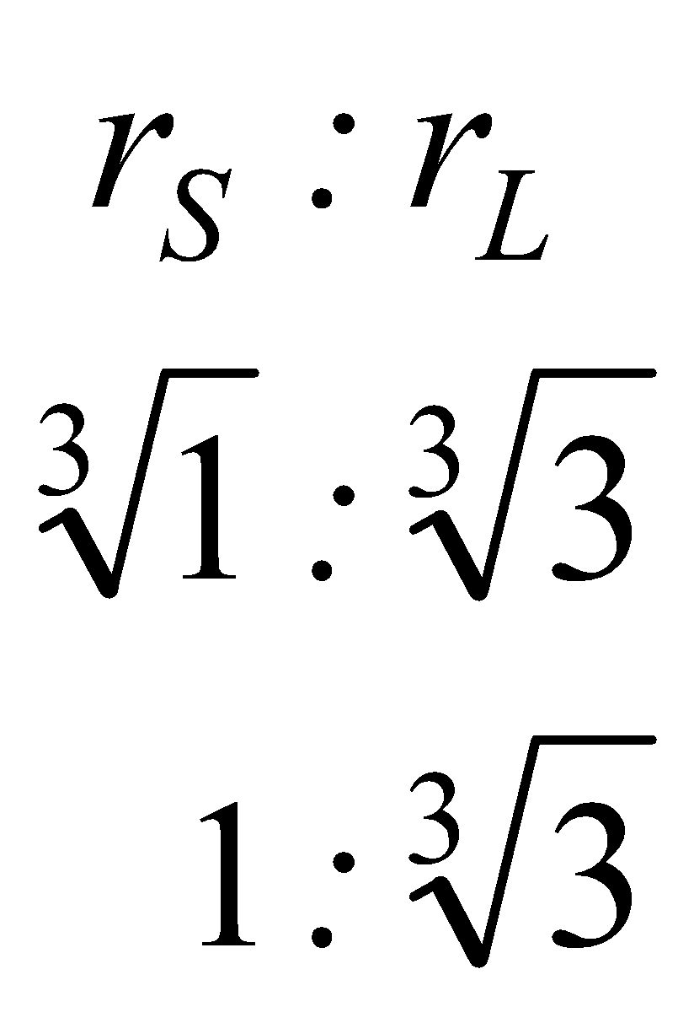

Since the radius of the large cone is 4, we have

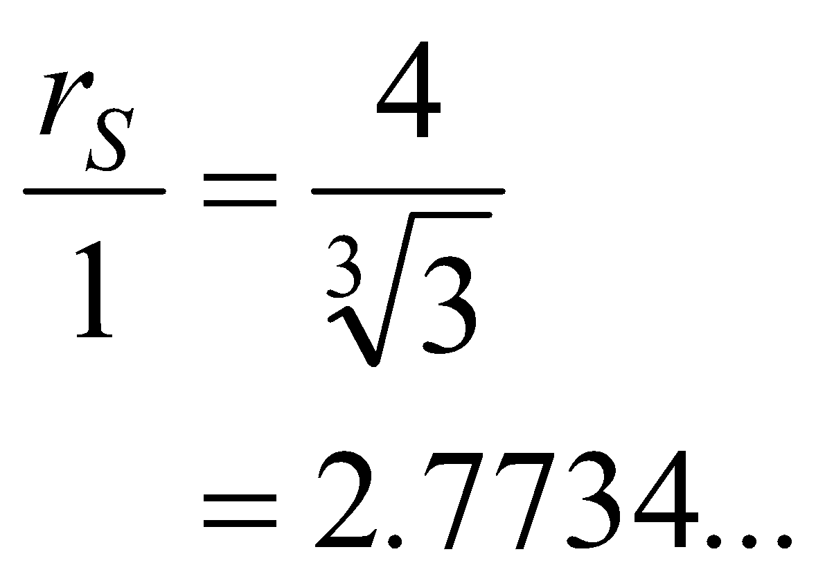

The closest answer is 2.8.

The answer is E.

# **Question 7**

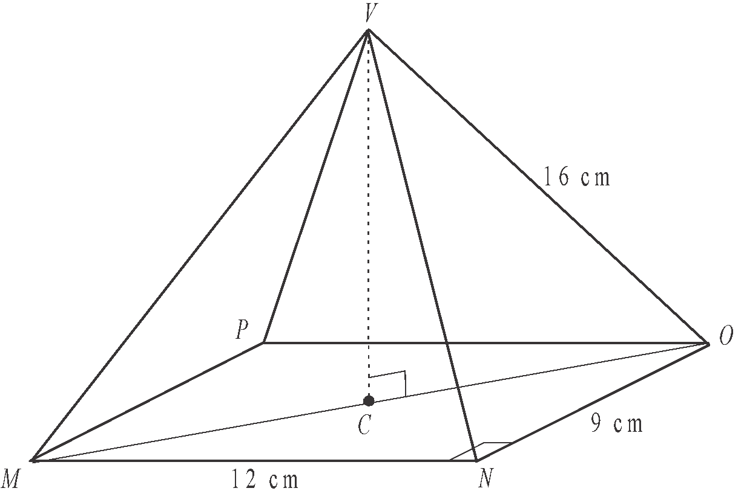

In Δ*MNO,* 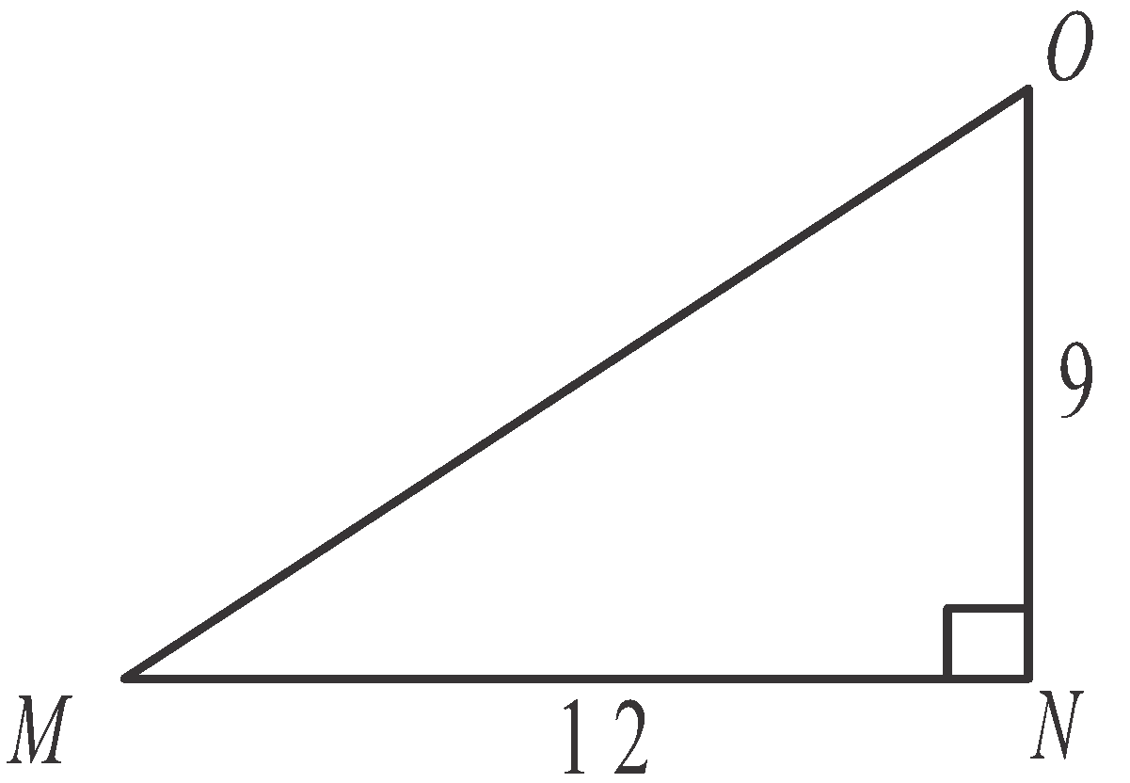

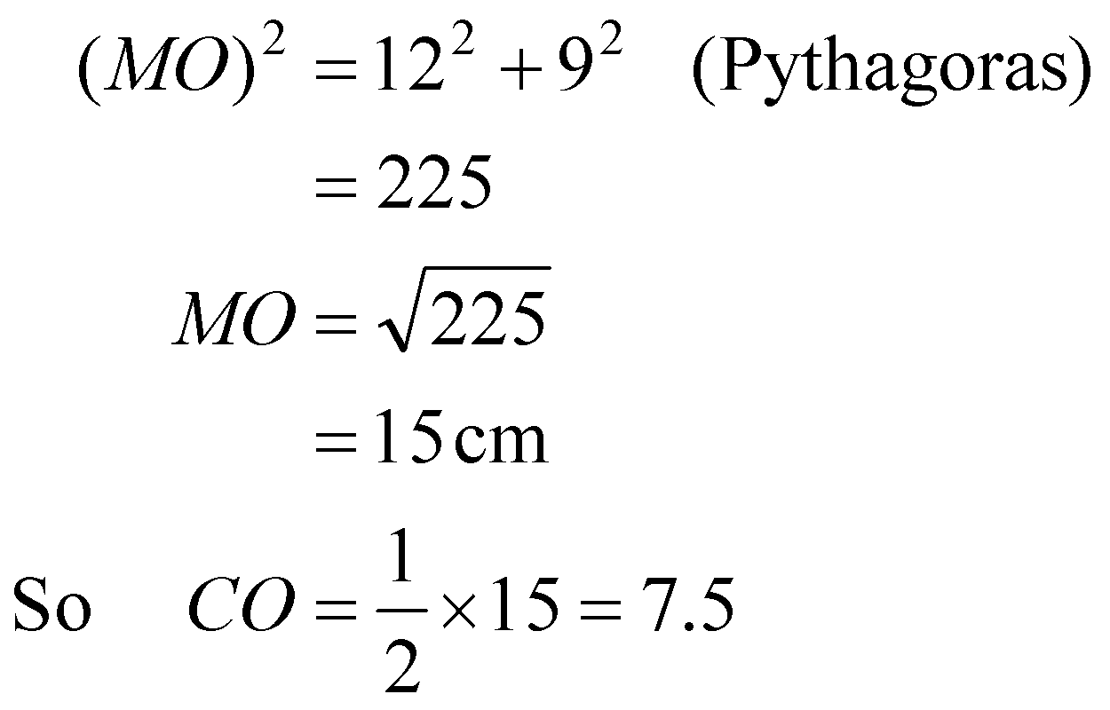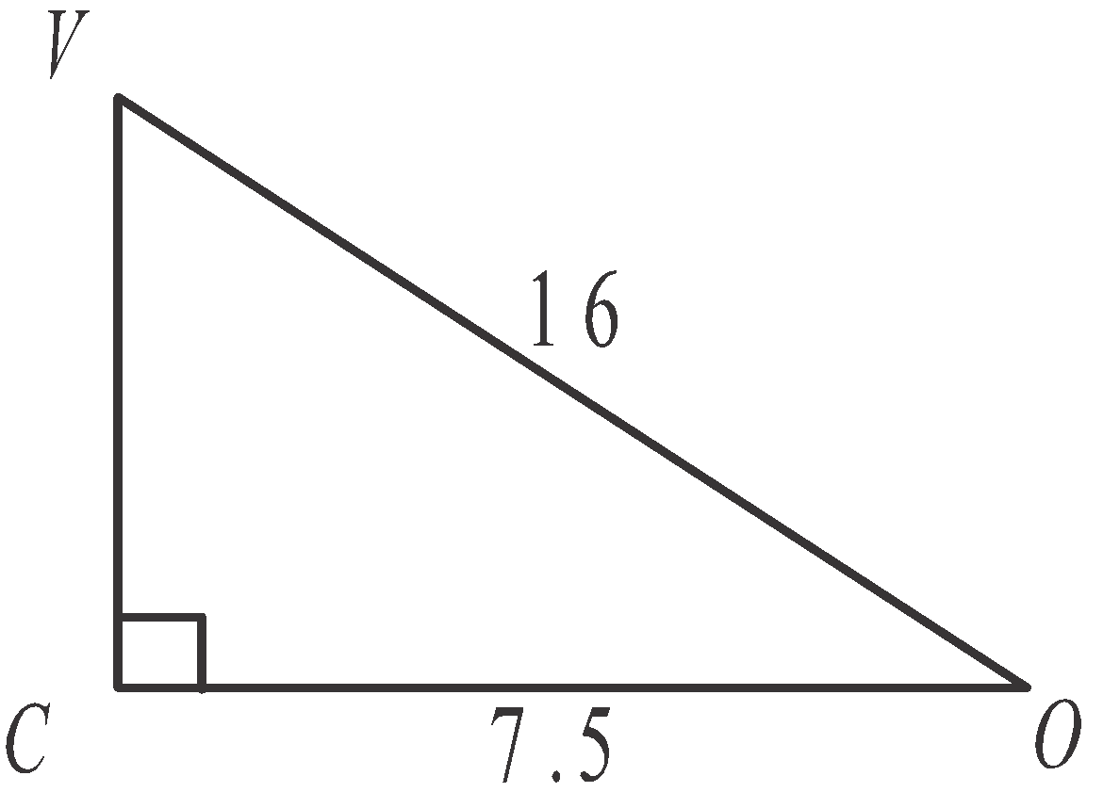

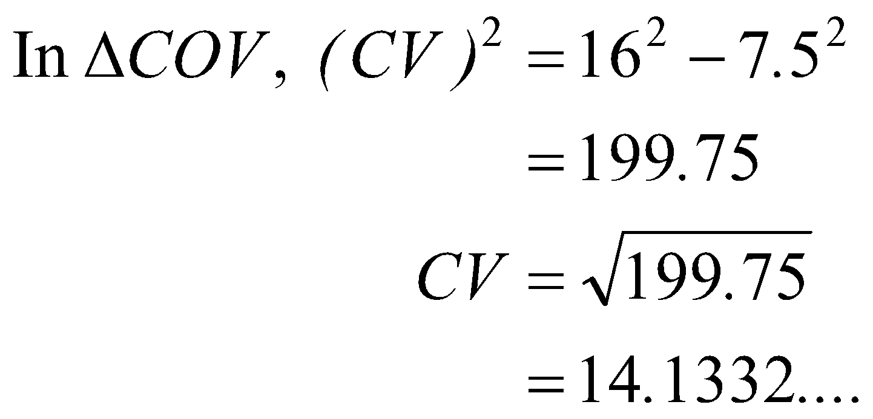

The height of the pyramid is closest to 14.1 cm.

The answer is B.

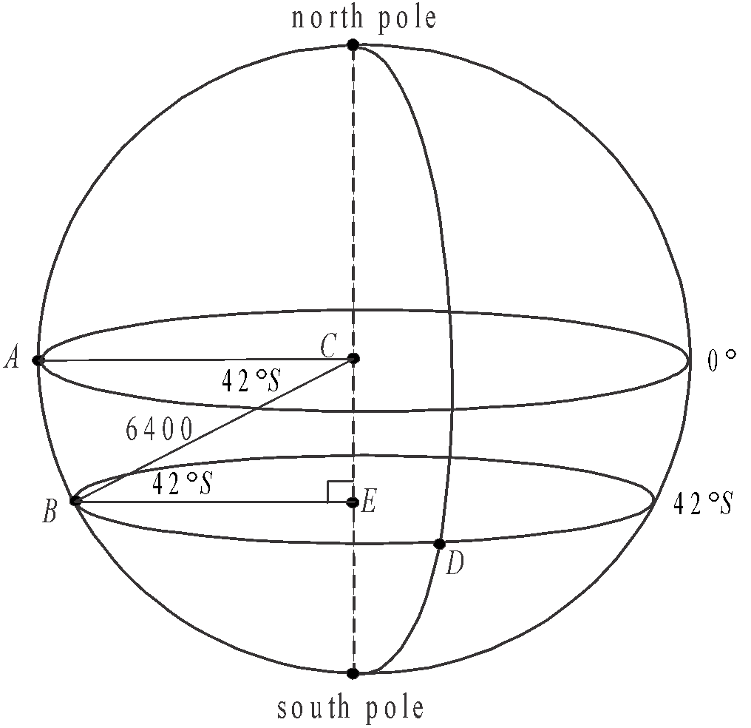

# **Question 8**

The quadrilateral *ACEB* lies in a vertical plane.

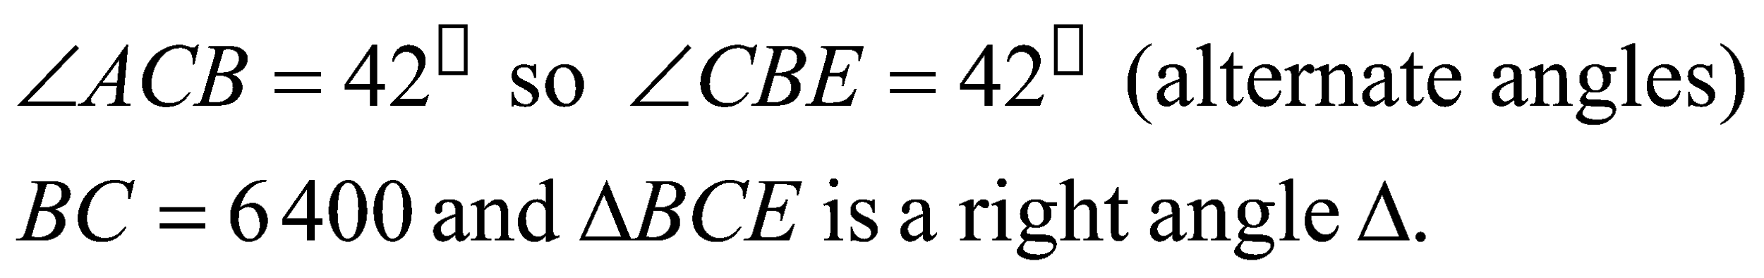

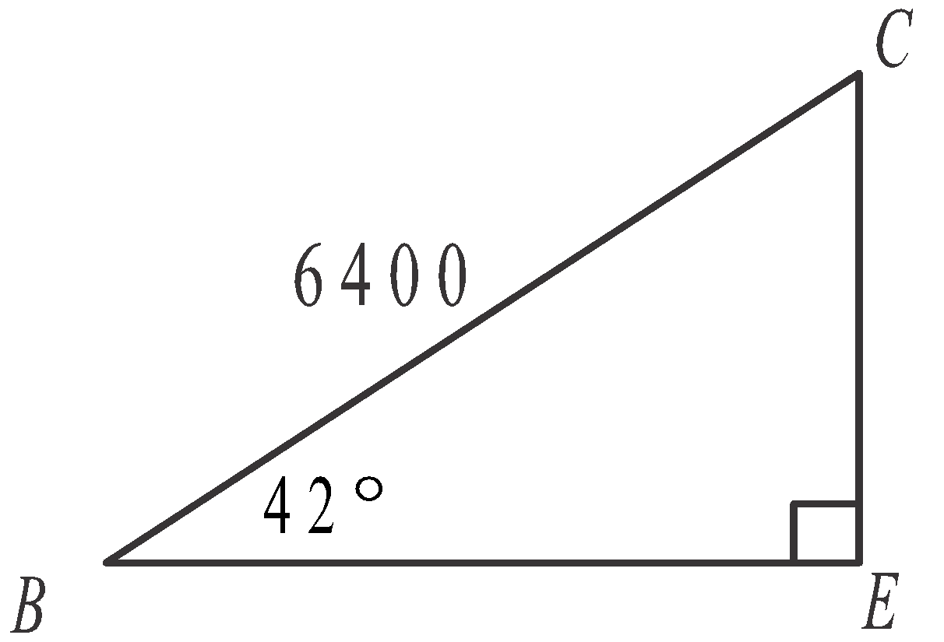

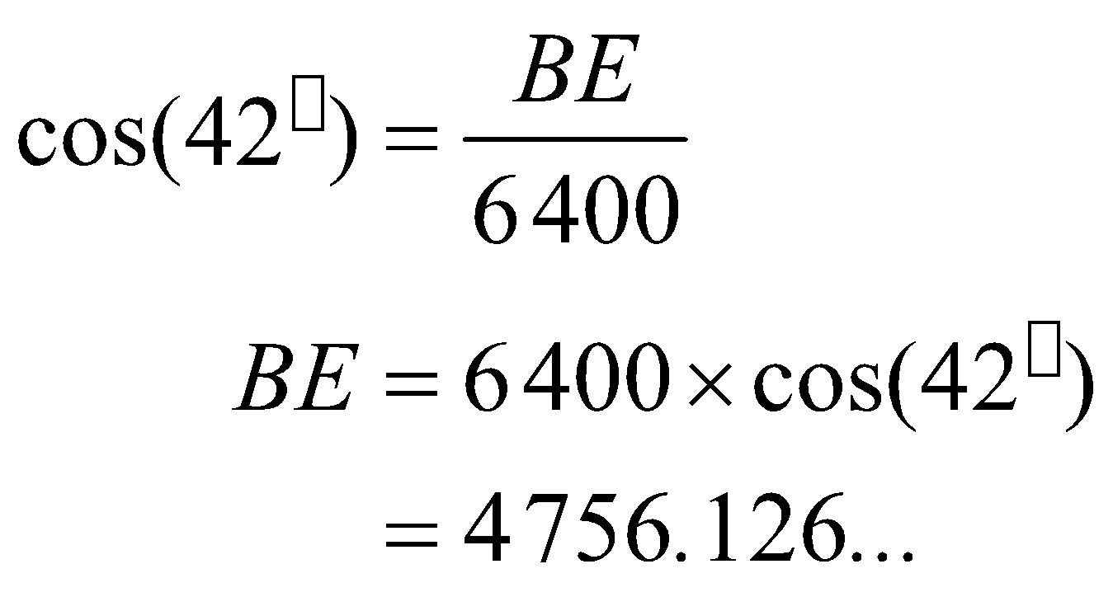

In sector *BED*, the arc length *BD* is given by

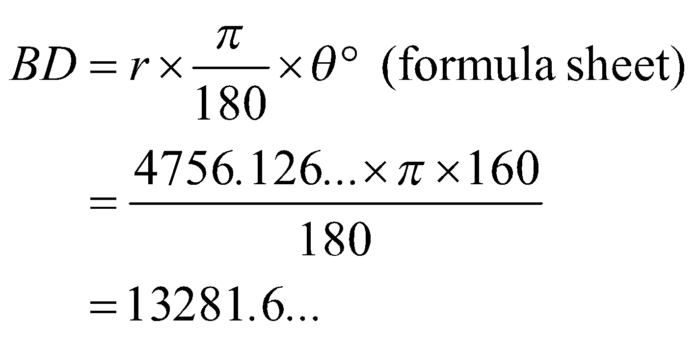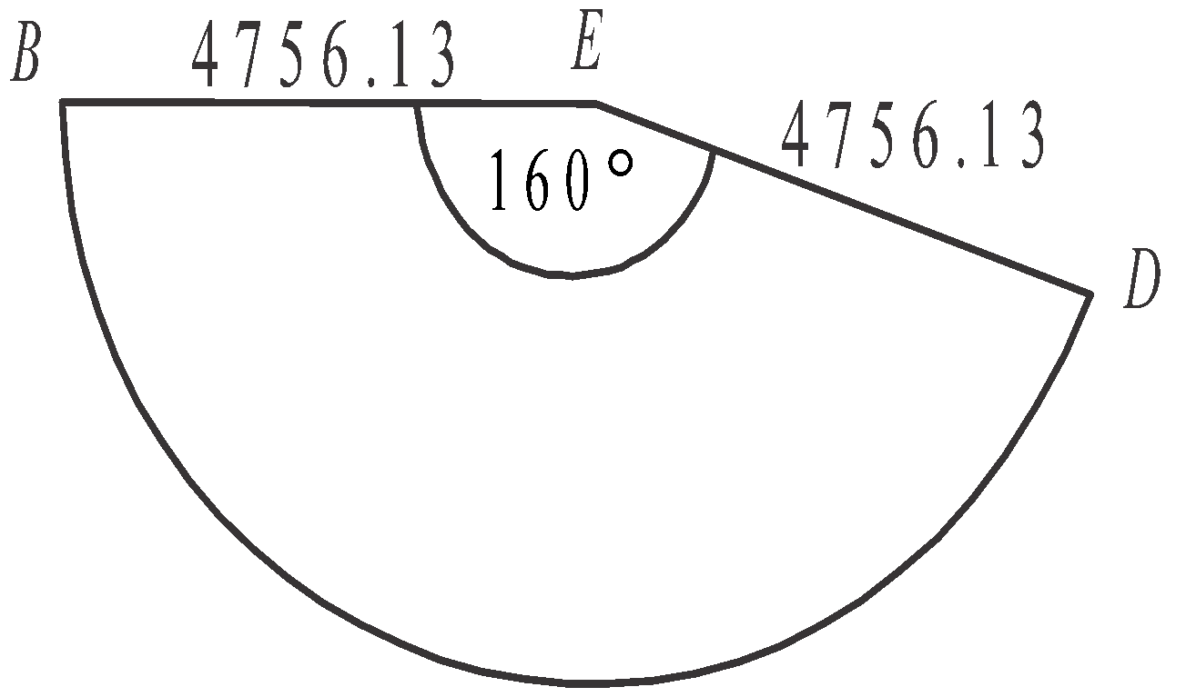

The closest answer is 13 282.

The answer is D.

# **Module 4: Graphs and relations**

**Question 1**

The graph passes through the points 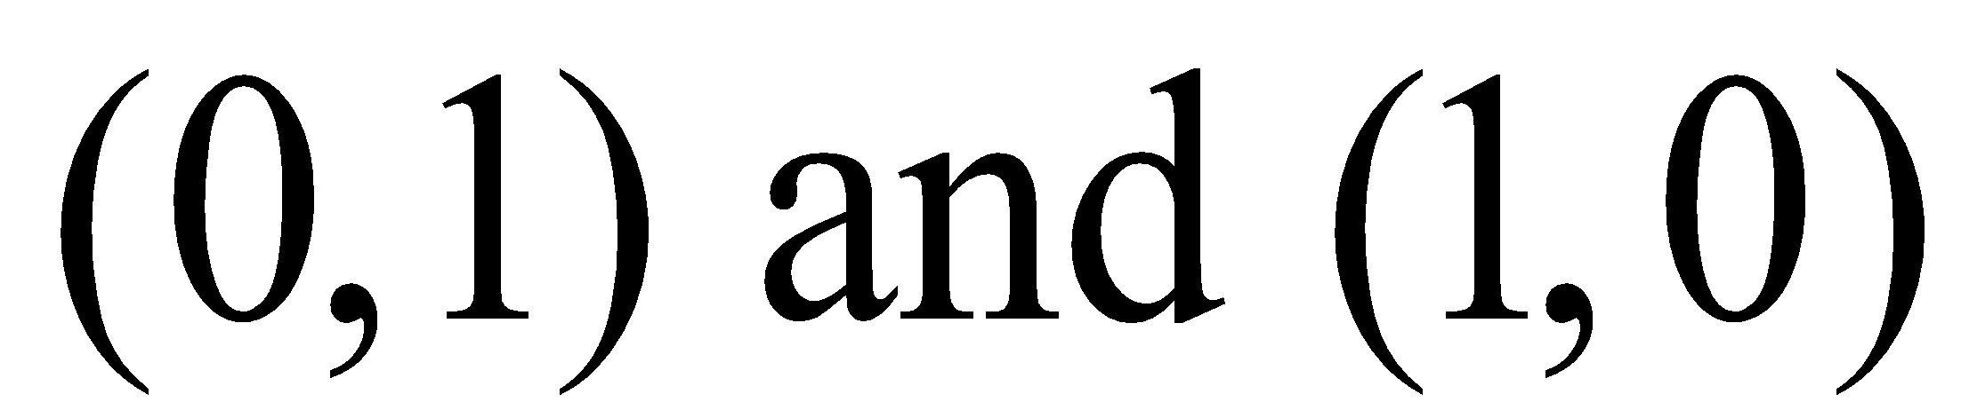.

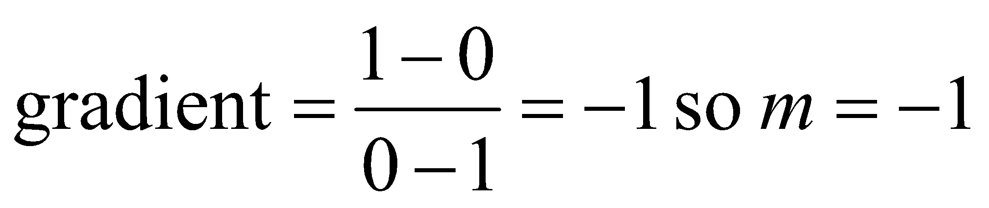

Using the equation of a straight line,

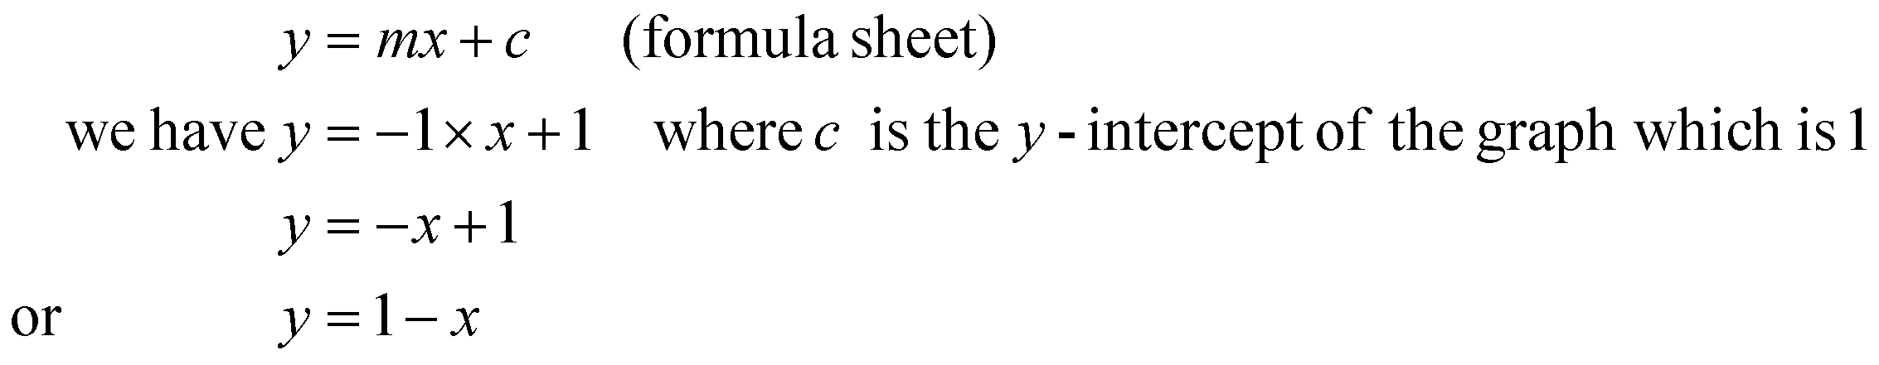

The answer is C.

# **Question 2**

For the point (1,2), 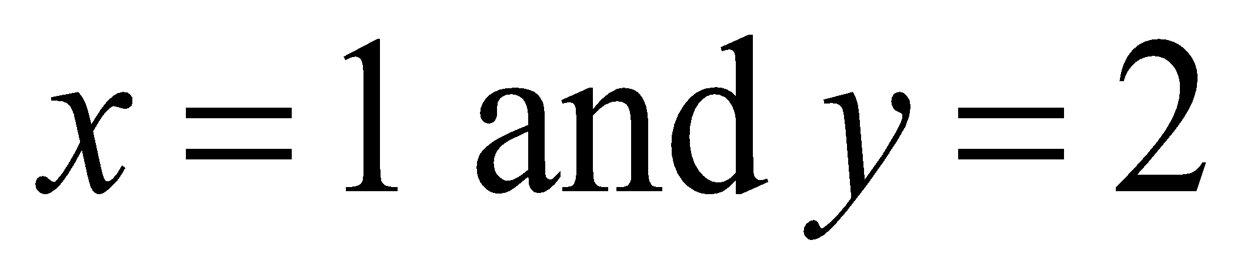.

The inequality  is not satisfied since 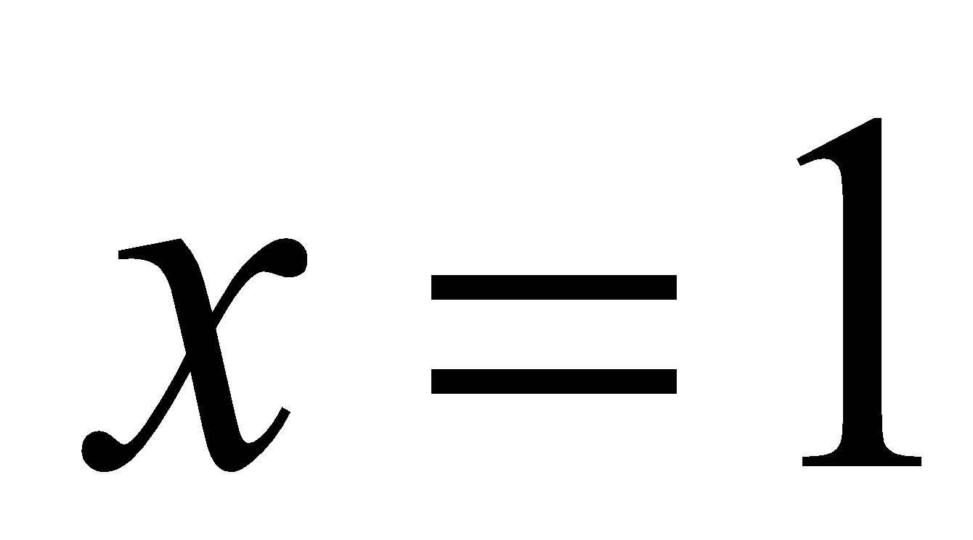.

The inequality  is not satisfied since 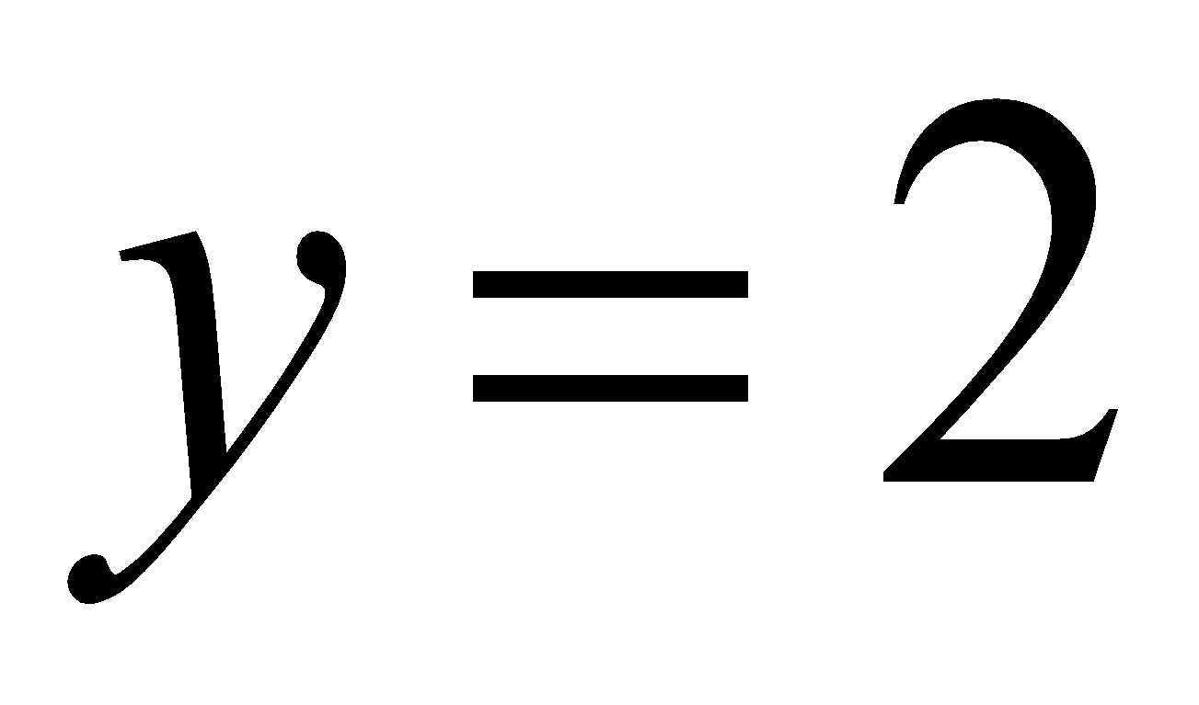.

For ,

substitute .

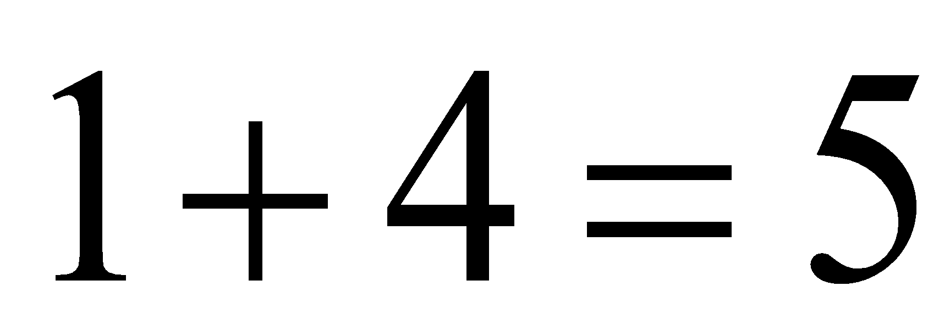

Since 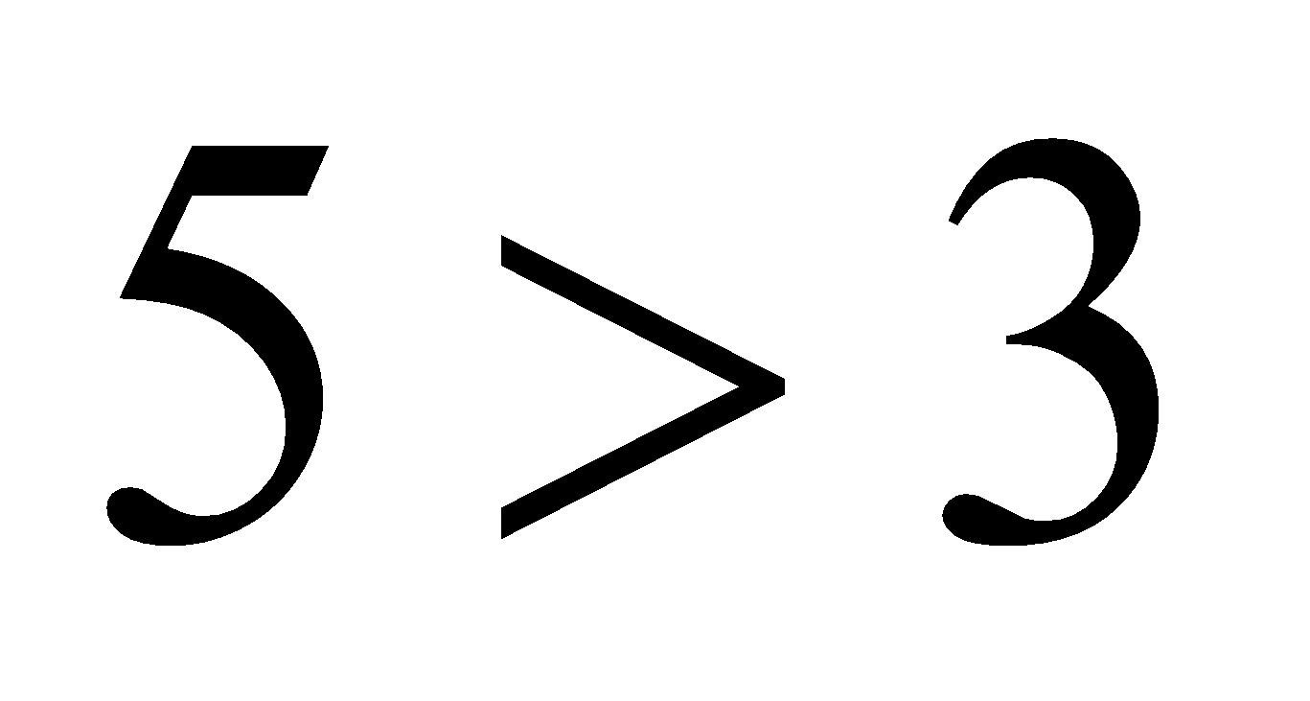 the inequality is not satisfied.

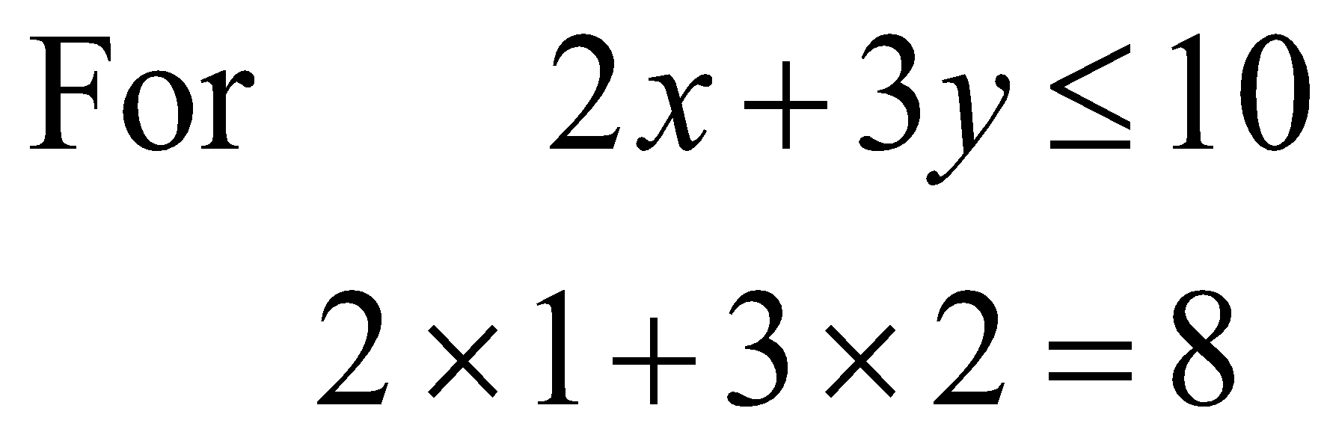

Since  the inequality is satisfied.

The answer is D.

# **Question 3**

Substitute the coordinates of the point (4, 15) into the equation

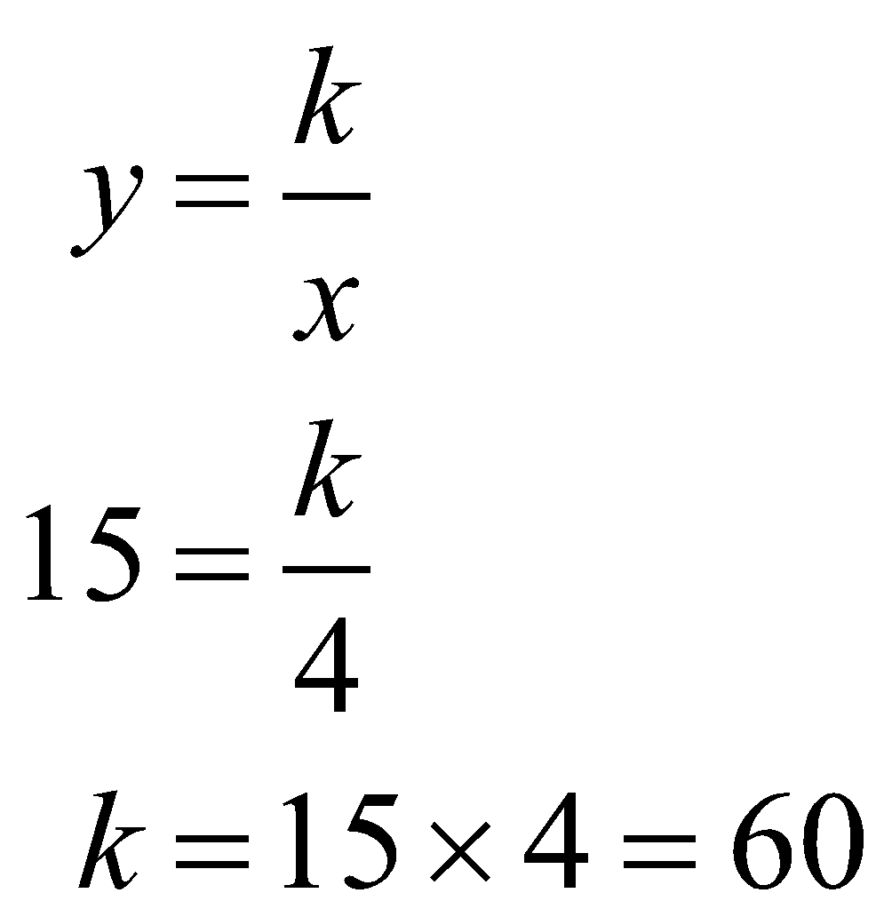

The answer is E.

# **Question 4**

The minimum value of the objective functions will occur at a corner point or points.

From the graph we see that they are located at (3, 1), (5, 3), (5, 5), (4, 5) and (2, 4).

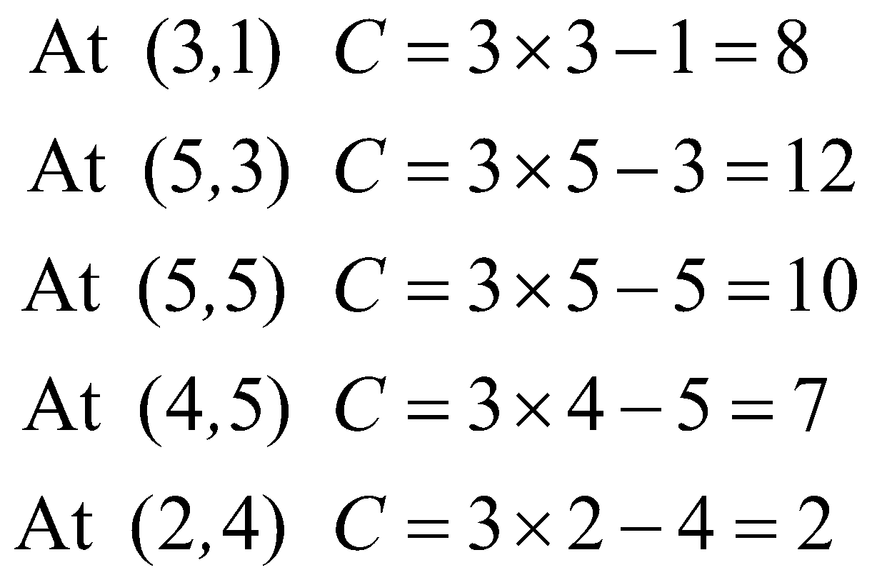

The minimum value of the objective function is 2.

The answer is A.

# **Question 5**

For  the equation of the graph is 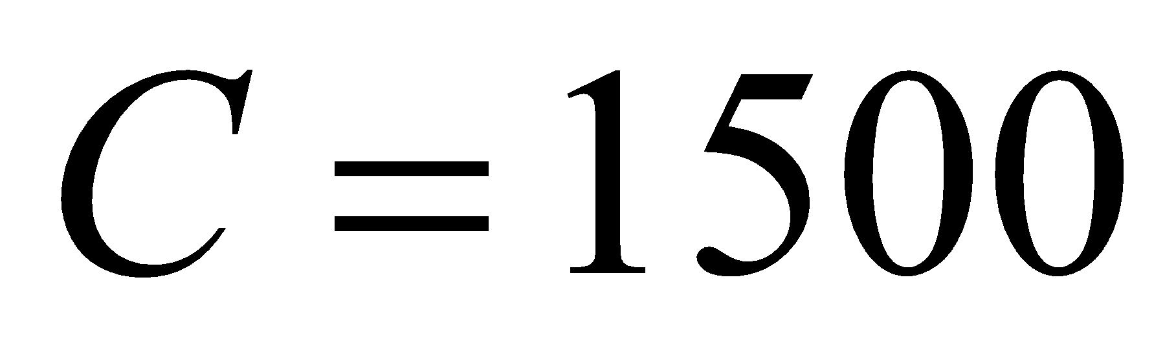.

For , the graph has a gradient of 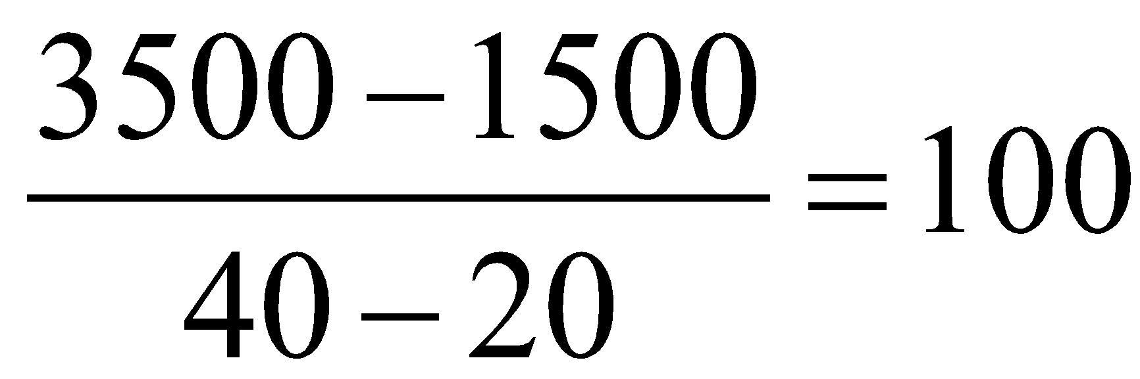.

The equation of a straight line is given by 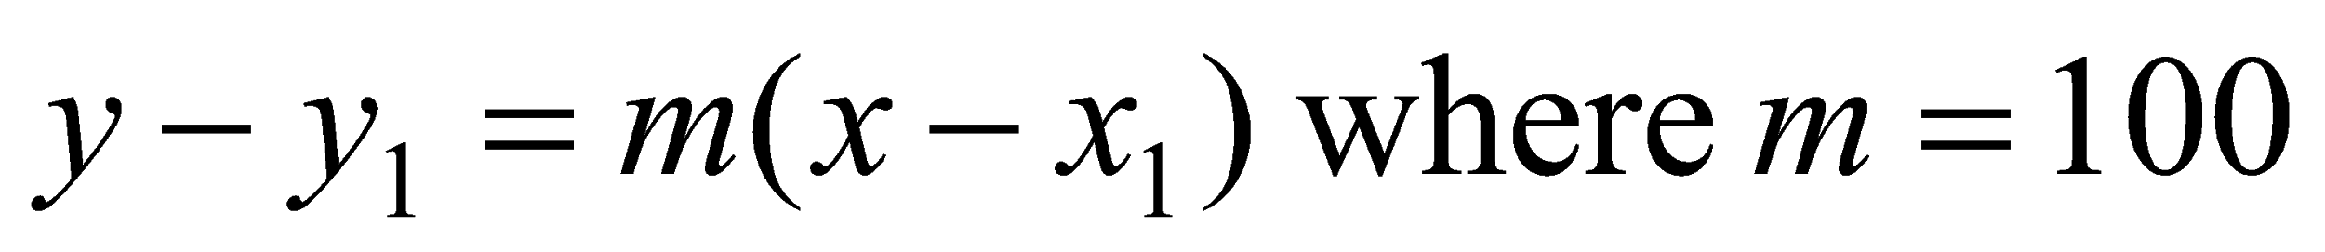 and we can use the point  if you prefer, it makes no difference.

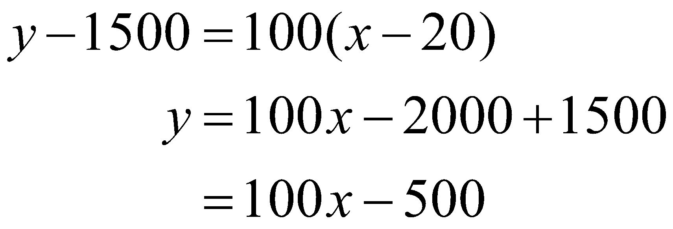

Using our variables, we have 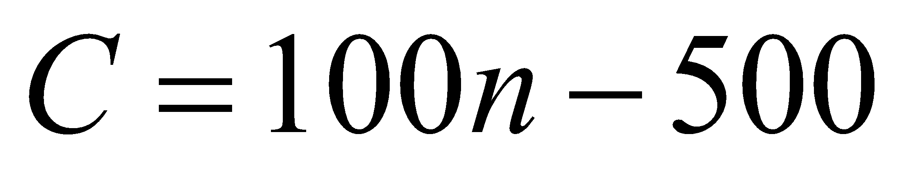.

The rule that could describe the graph is

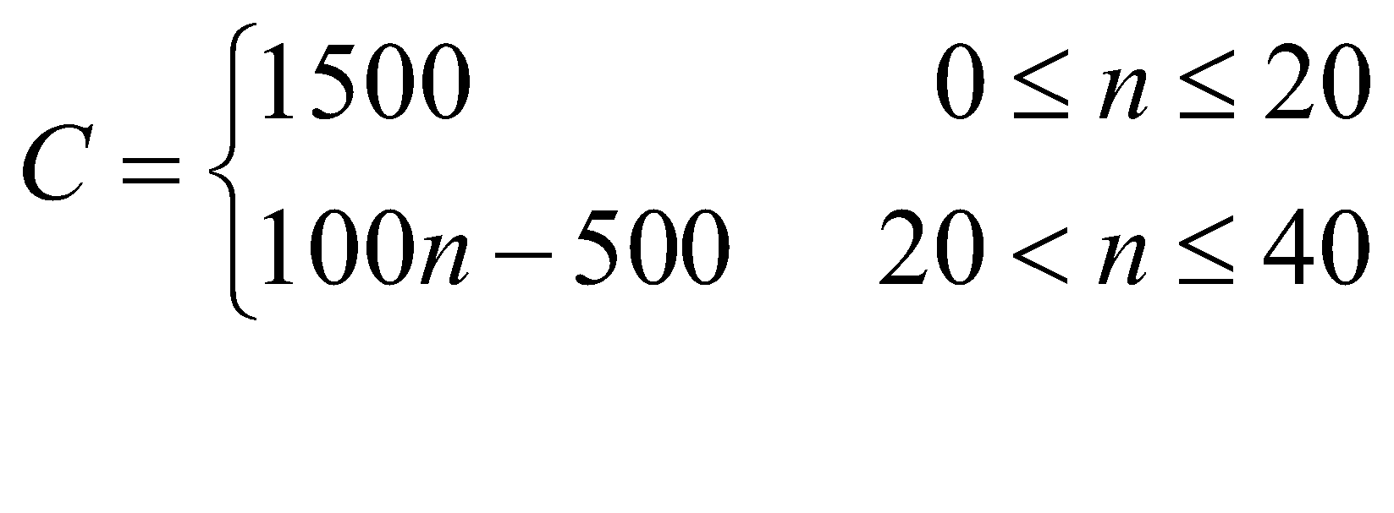

The answer is B.

# **Question 6**

The opening price of the stock is given by the intercept on the vertical axis which is $3, not $4.

The price of the stock reached its maximum on day 3, not day 5.

The price of the stock increased on days 1, 2, 3, 6, 7 and 9, that is, on six days out of the ten, not five days out of the ten days.

The price of the stock increased on day 9 by approximately 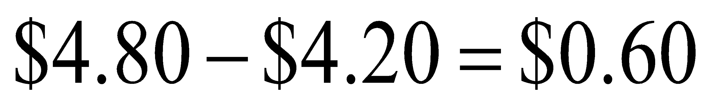.

On days 2, 3 and 6 the price of the stock increased by approximately $0.80.

The price of the stock opened at $3 and closed at $1 over the ten day period. On average this shows a change of 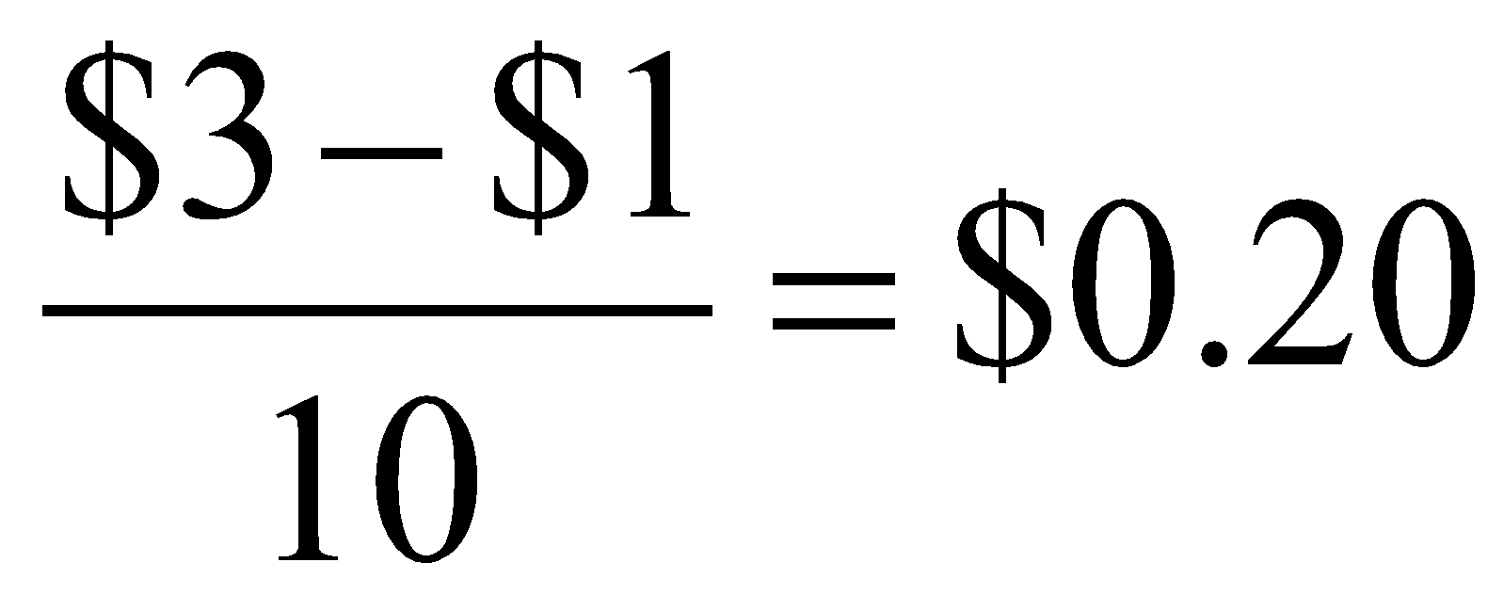.

The answer is E.

**Question 7**

Let *n* be the number of students Peter tutored last week.

Peter’s costs are given by

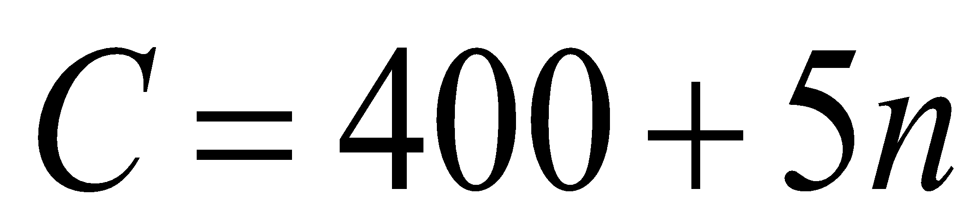

Peter’s revenue is given by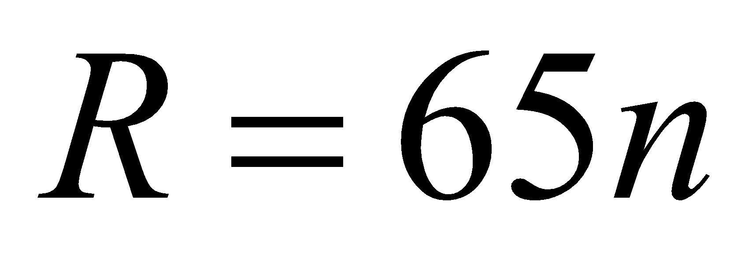.

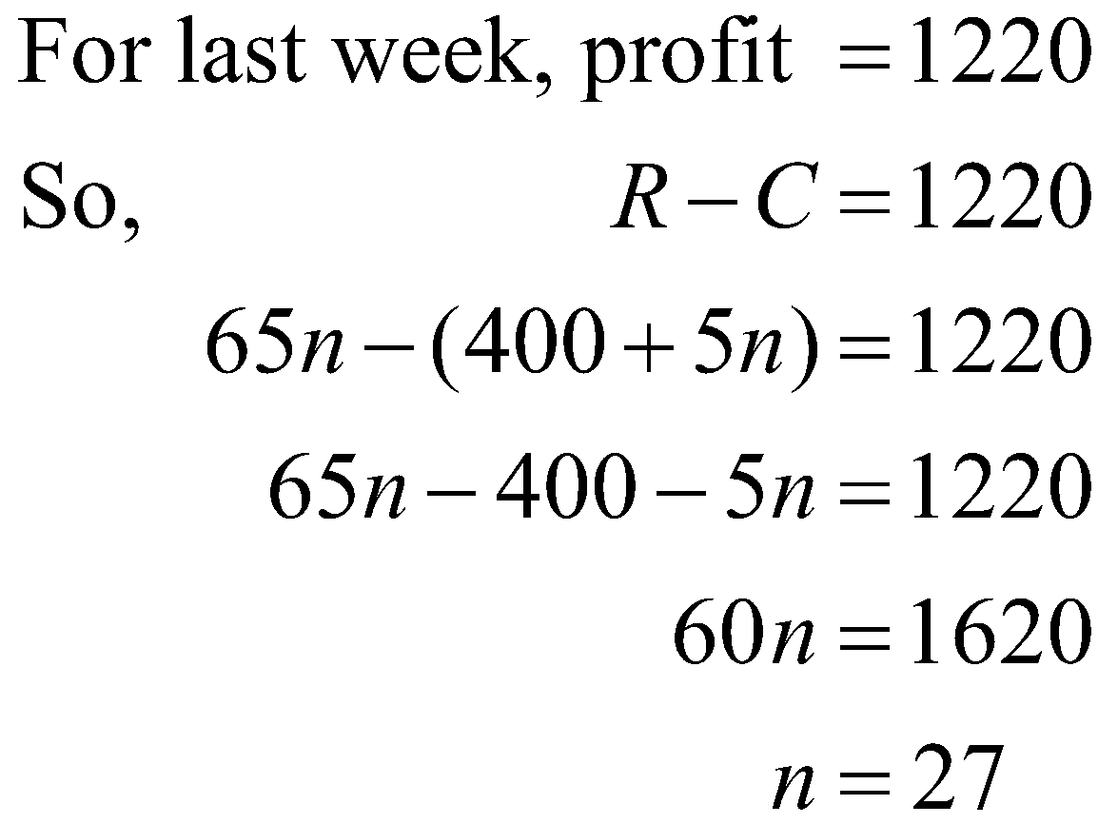

Peter tutored 27 students last week.

The answer is D.

# **Question 8**

The inequalities that describe the set of conditions are

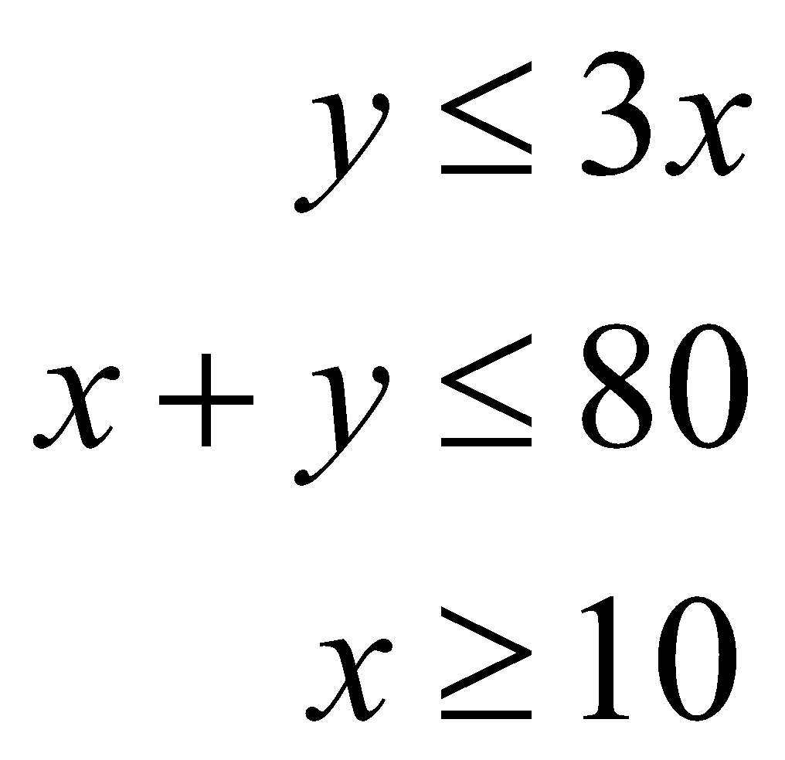



The boundaries of each of these inequalities are shown correctly on each of the options A–E. It is the shading that is in question.

Options A and B must be eliminated because they have shading for.

Option E must be eliminated because it has shading for .

Option D must be eliminated because it has shading for 

The answer is C.